Software Design Document

for

<GET HOTEL SYSTEM>

Version 1.0

Prepared by <H21_GREEN>

<RIVERFRONT SENTRAL HOTEL>

<6 March 2024>

Table of Contents

Table of Contents ii

Revision History ii

1. Introduction 1

1.1 Purpose 1

1.2 Scope 1

2. System Software 3

2.1 List of Folder or Package 3,4

2.2 User Interface for each UI Files 5

2.2.1 Homepage 5

2.2.2 Room Type Page 6,7

2.2.3 Sign Up Page 8

2.2.4 Login Page 9

2.2.5 Service Page 10,11,12,13

2.2.6 Book Now Page 14

2.2.7 Check Reservation Page 15

2.2.8 Contact Us Page 16

2.2.9 Admin Page 17

2.2.10 Admin Check Reservation Page 18

2.2.11 Admin Customer Payment Page 19

2.2.12 Admin Check Room ID Page 20

2.2.13 Admin Check Room Type Page 20

2.2.14 Import Data Page 21

2.2.15 Admin Customer List Page 21

2.2.16 Log Out Page 22

2.3 Source Code for All Files 22

3. Database 23

3.1 ER-Diagram for the Database 23

3.2 Sereenshot of Database 24

3.2.2 Admin Table 25

3.2.3 Client Table 26

3.2.4 Room Type Table 27

3.2.5 Registration Table 28

3.2.6 Room Table 29

3.2.1 Service Table 30

3.3 SQL Statement for the Database / No-SQL Rules in Firebase 31,32,33

|  |  |  |  |
| --- | --- | --- | --- |
| **Name** | **Date** | **Reason for Changes** | **Version** |
| 1. TAN JIN WAN 2. MUHAMMAD LUQMAN HAZIM BIN SULAIMAN 3. MUHAMMAD ANAZ AZZAMUDDIN BIN AZHAR 4. NABIL AIMAN BIN ADNAN | 6 March 2024 | Initial release | 1.0 |

Revision History

# Introduction

In the context of the "Get Hotel System," Software Development becomes the architect of seamless experiences. Enter the world of System Design and Development (SDD), a pivotal phase in crafting the backbone of this revolutionary hotel management software. SDD is the disciplined art of transforming abstract concepts into tangible, user-friendly solutions, laying the foundation for a sophisticated and efficient Get Hotel System. Join us on this journey as we unravel the intricacies of SDD, exploring how it empowers the hospitality industry to elevate customer experiences through intuitive and robust software solutions.

## Purpose

The primary purpose of System Design and Development (SDD) in the context of the Get Hotel System is to architect a robust and efficient software solution that caters to the diverse needs of the hospitality industry. SDD serves as the blueprint for translating conceptual ideas into a functional and user-friendly system. By systematically designing and developing the software, the aim is to enhance the overall efficiency of hotel operations, streamline processes, and provide a seamless experience for both hotel staff and guests. Through meticulous planning and implementation, SDD ensures that the Get Hotel System not only meets but exceeds the expectations of users, contributing to the success of the hotel industry in delivering exceptional services in the digital age.

## Scope

The scope of System Design and Development (SDD) within the ambit of the Get Hotel System is expansive, encompassing a comprehensive range of functionalities and features to meet the diverse requirements of the hospitality sector. From reservation management and check-in processes to room allocation, billing systems, and beyond, SDD aims to meticulously design and develop a software ecosystem that seamlessly integrates these components. The scope extends to creating an intuitive user interface for both hotel staff and guests, ensuring a user-friendly experience. Additionally, SDD delves into the integration of cutting-edge technologies, such as mobile compatibility, cloud-based solutions, and data analytics, to elevate the system's efficiency. By addressing the intricacies of hotel operations, SDD not only optimizes day-to-day tasks but also lays the groundwork for future scalability and adaptability. The scope of SDD in the Get Hotel System is thus a forward-looking endeavor, poised to enhance the entire spectrum of hotel management processes.

# System Software

## List of Folder or Package

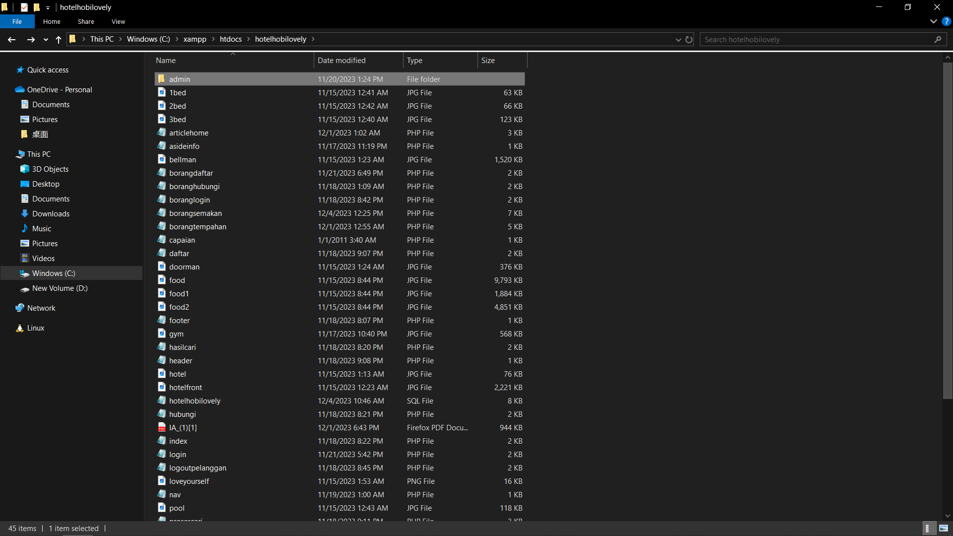

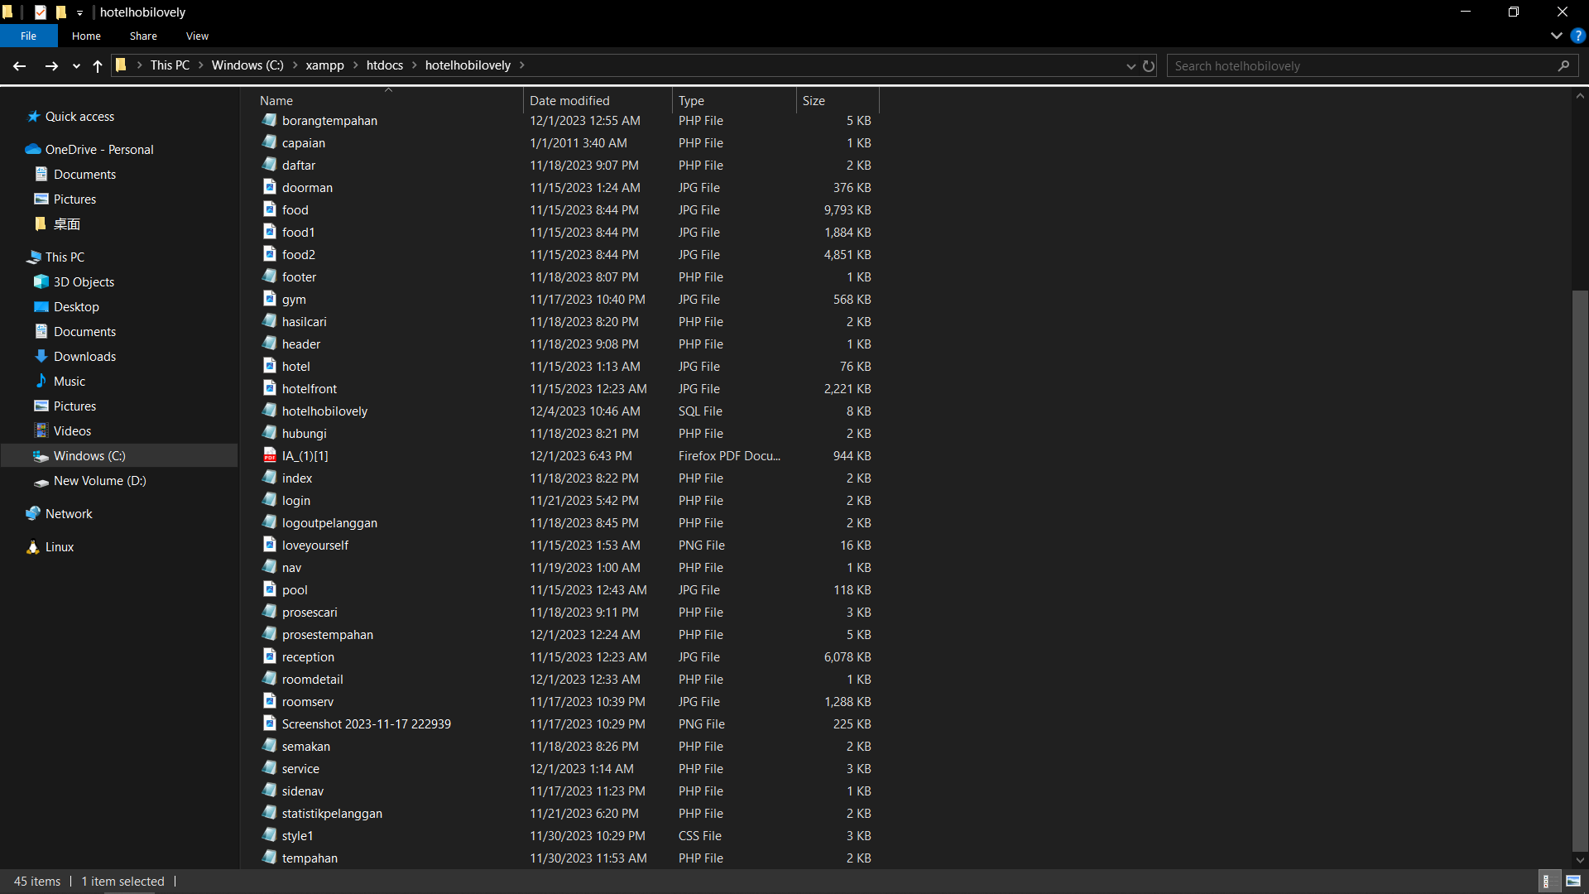

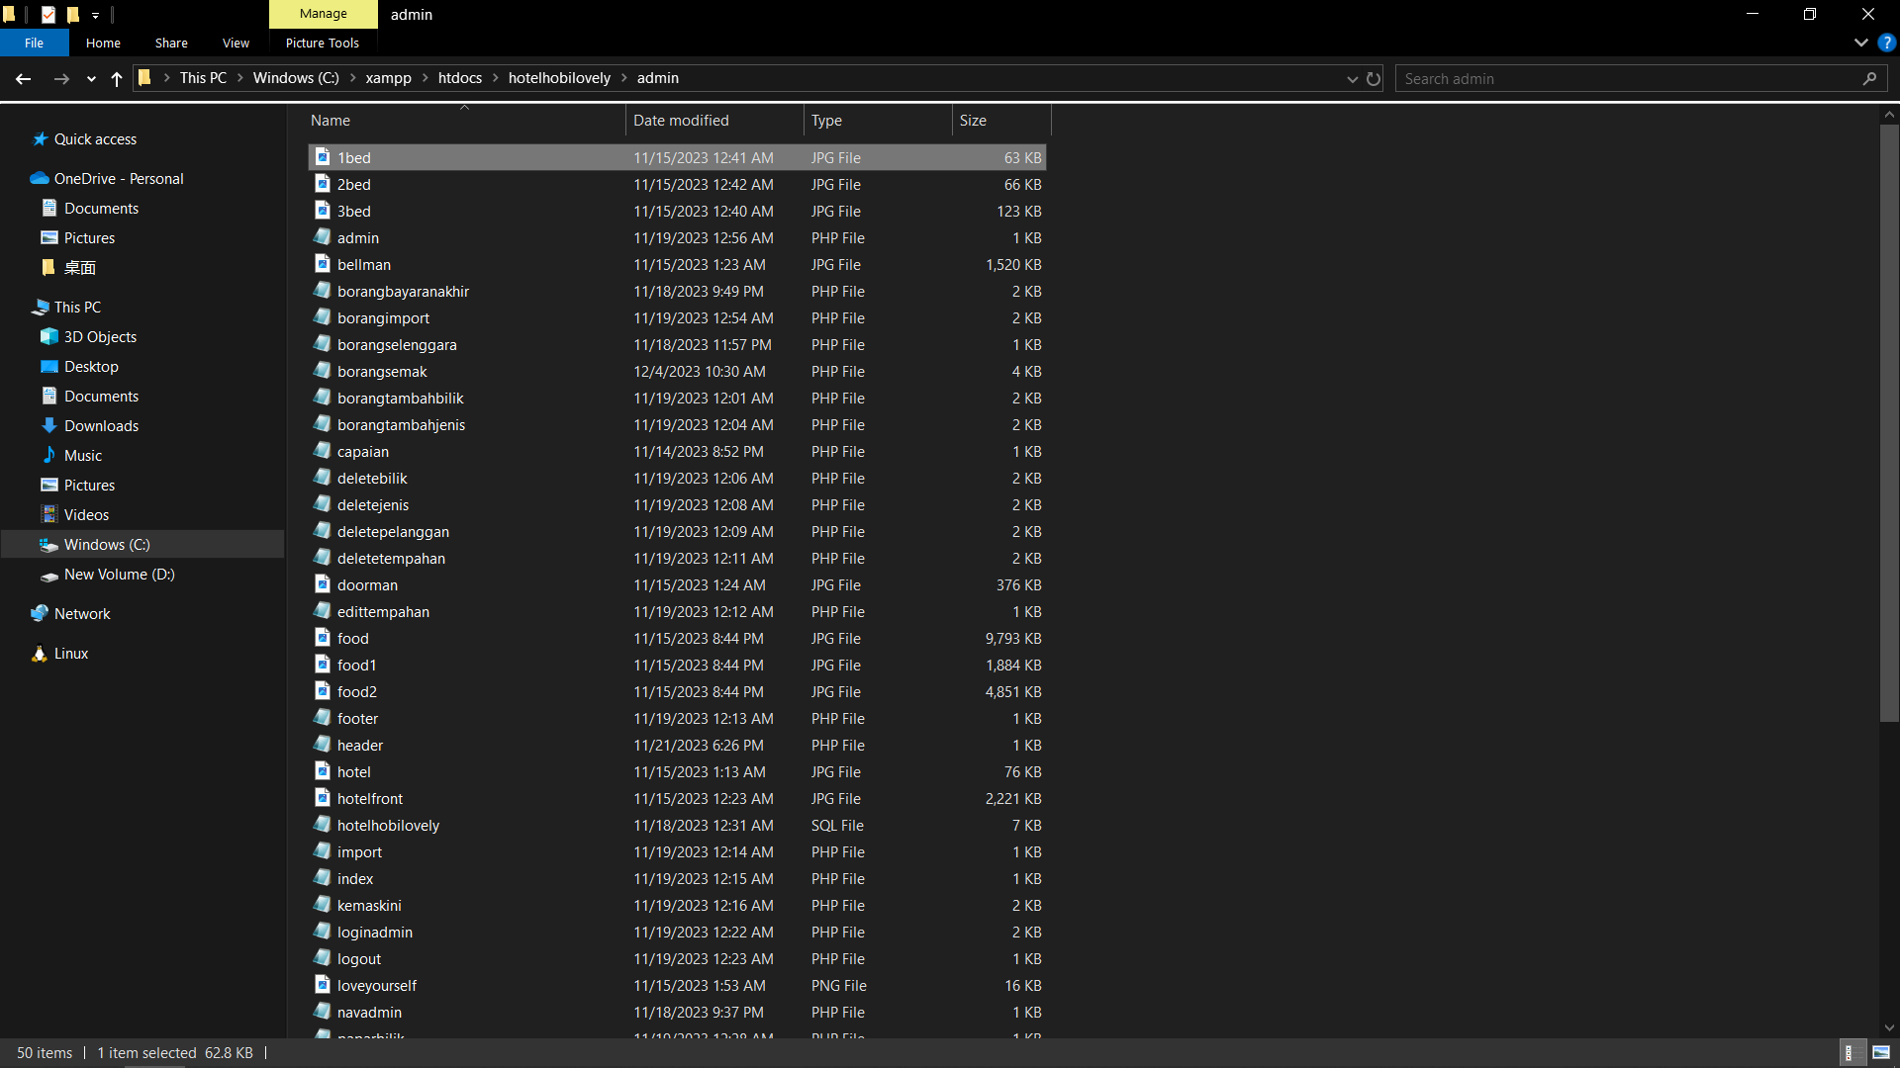

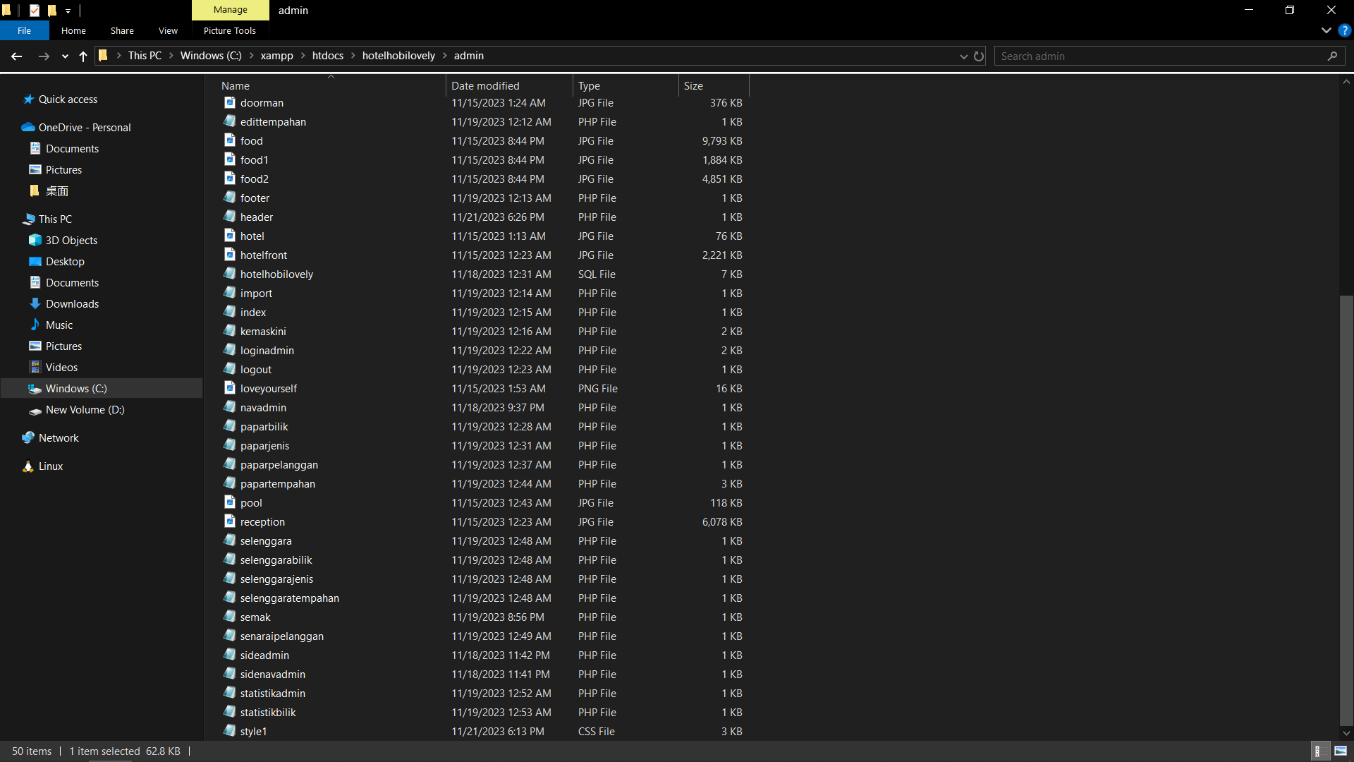

## User Interface for each UI Files

### Homepage

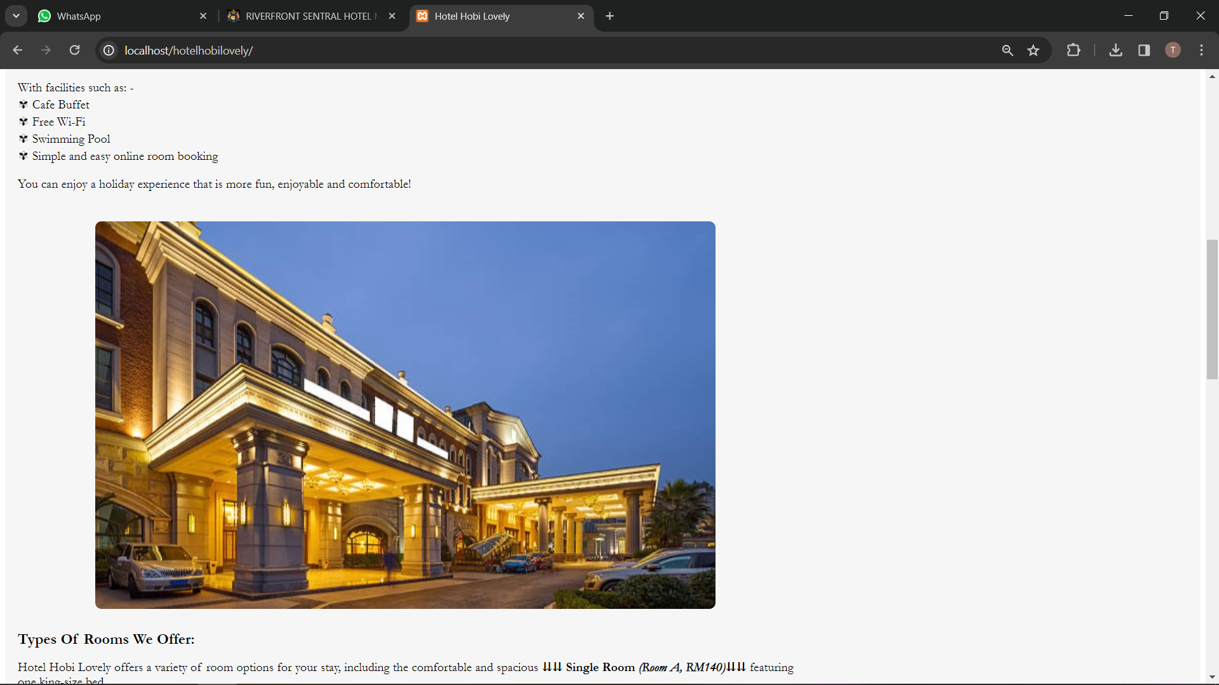

### Room Type Page

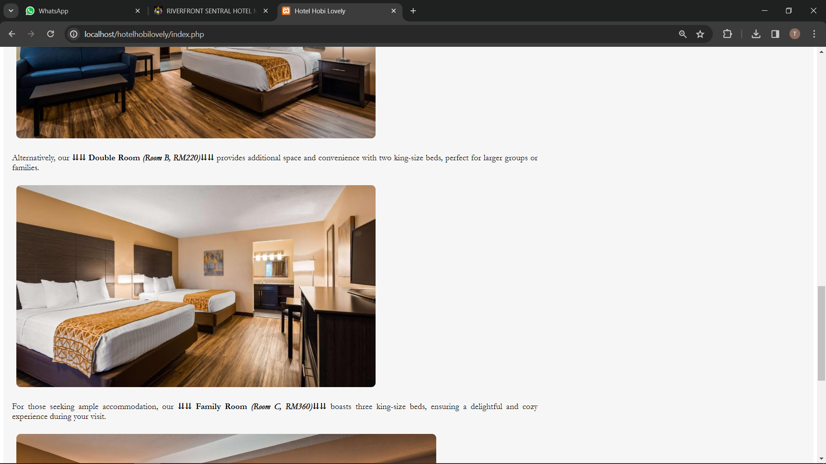

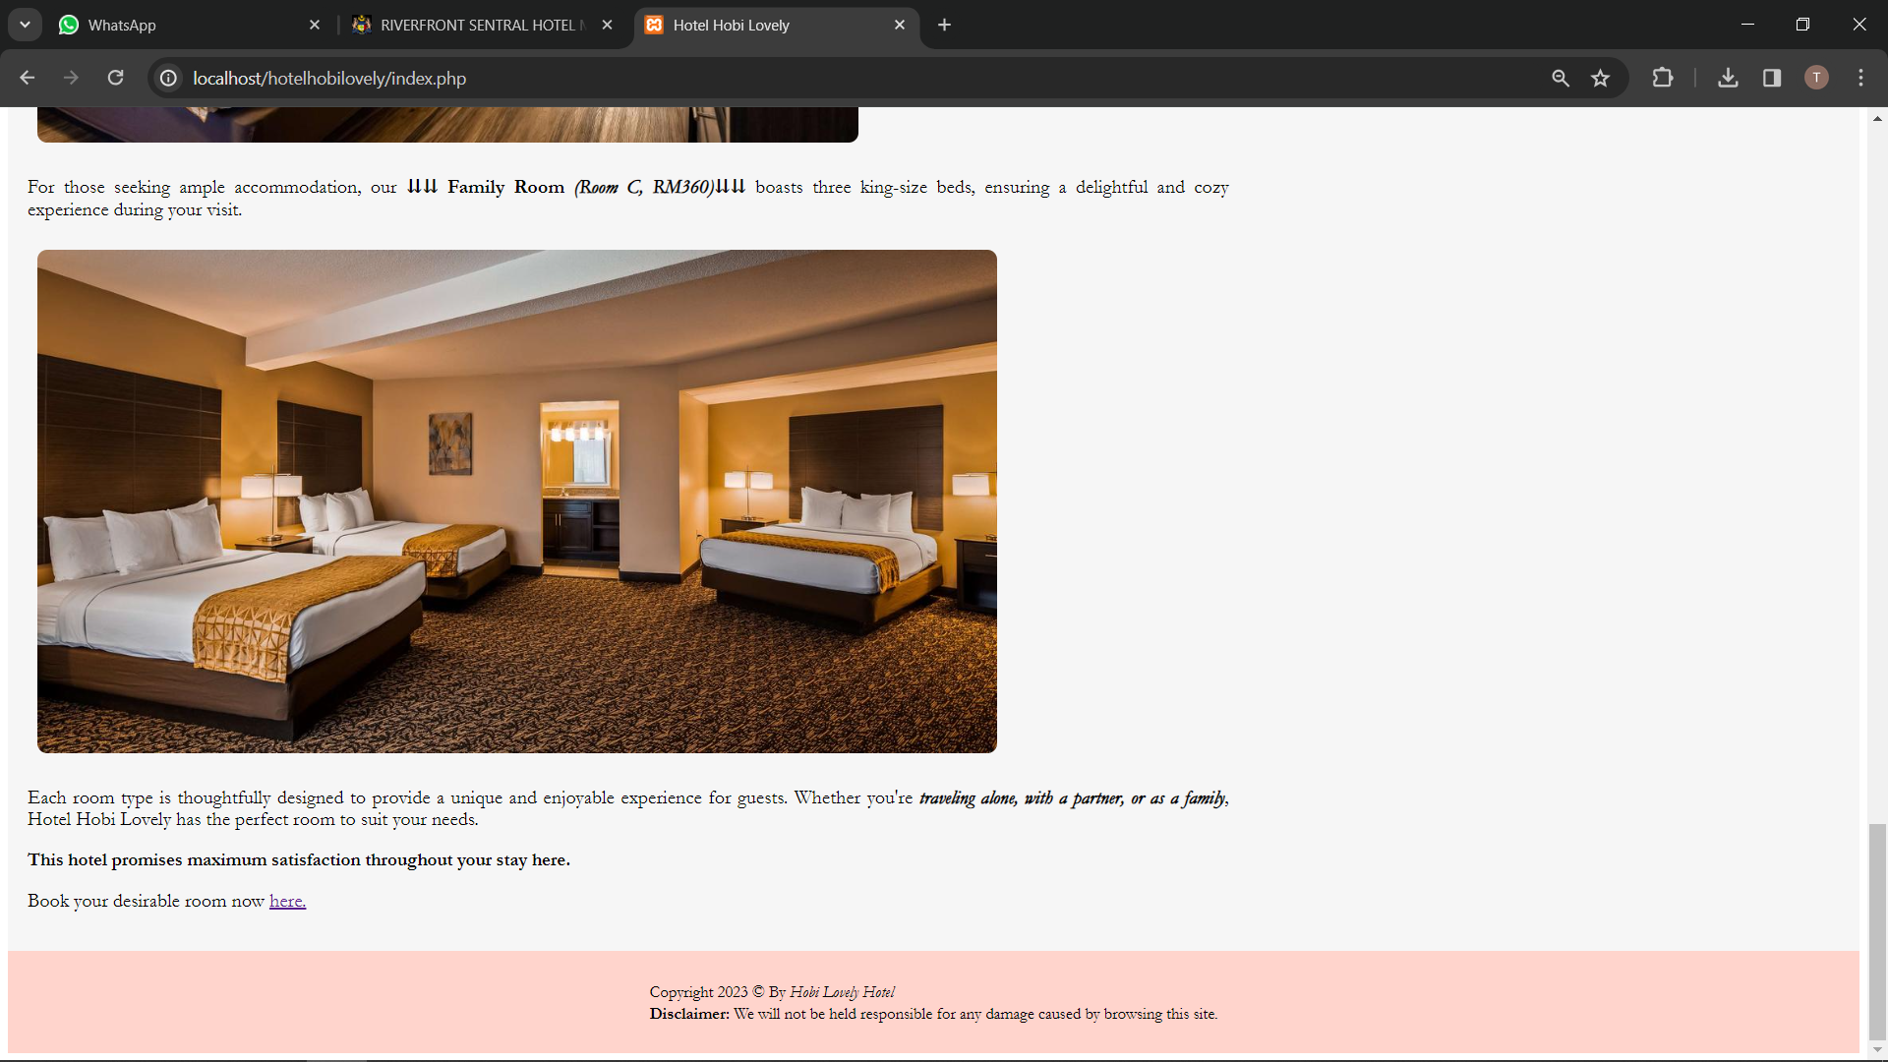

### Sign Up Page

### Login Page

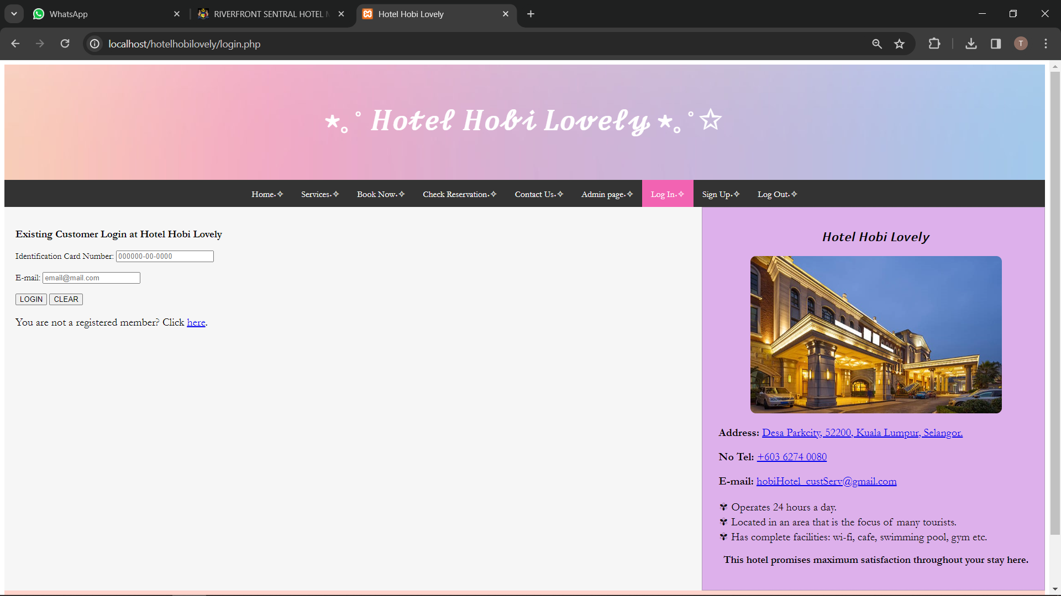

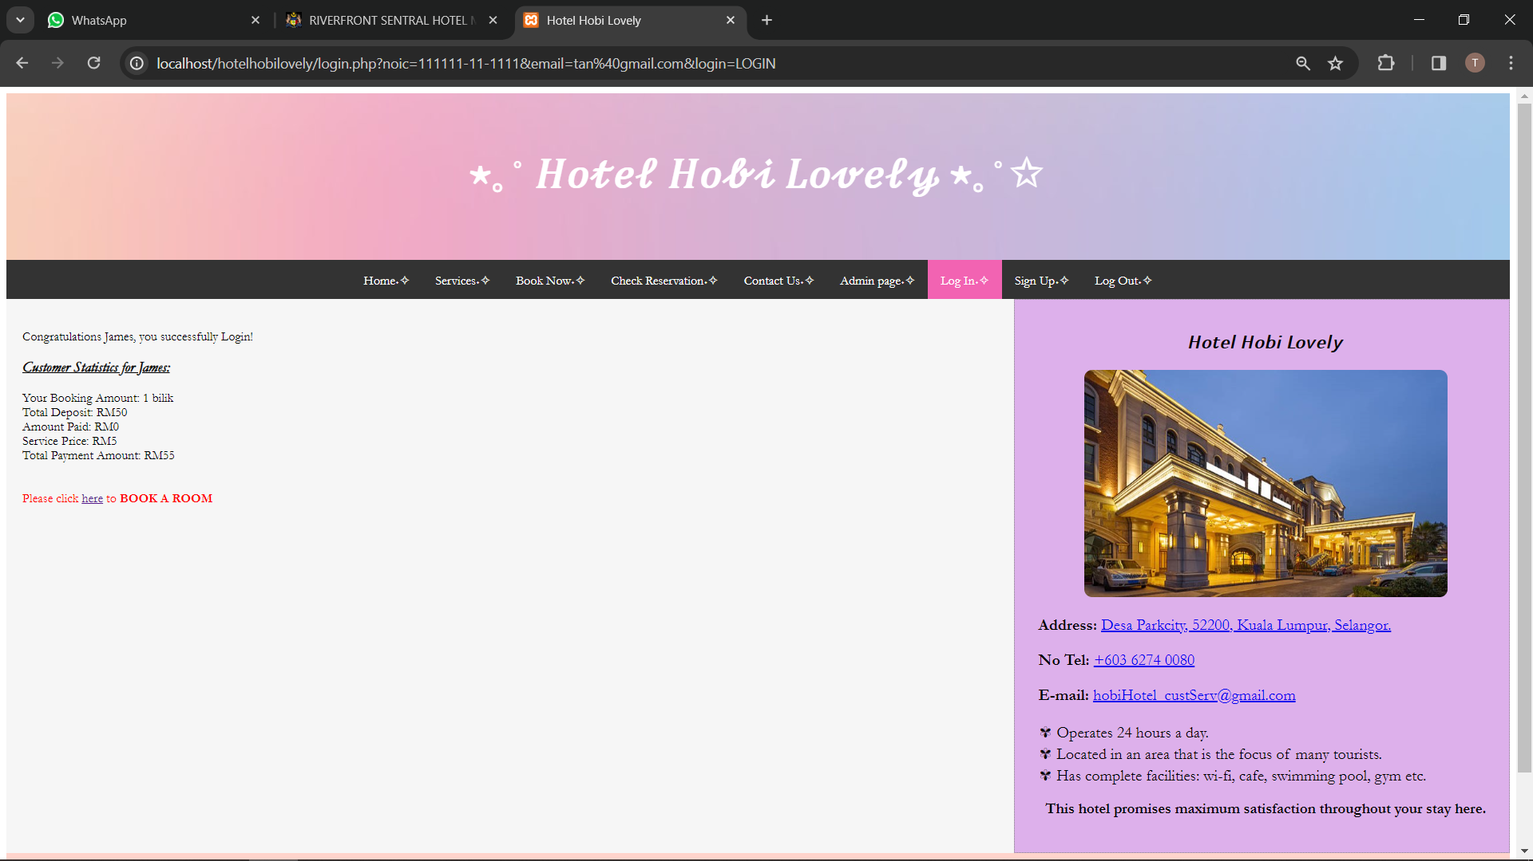

### Service Page

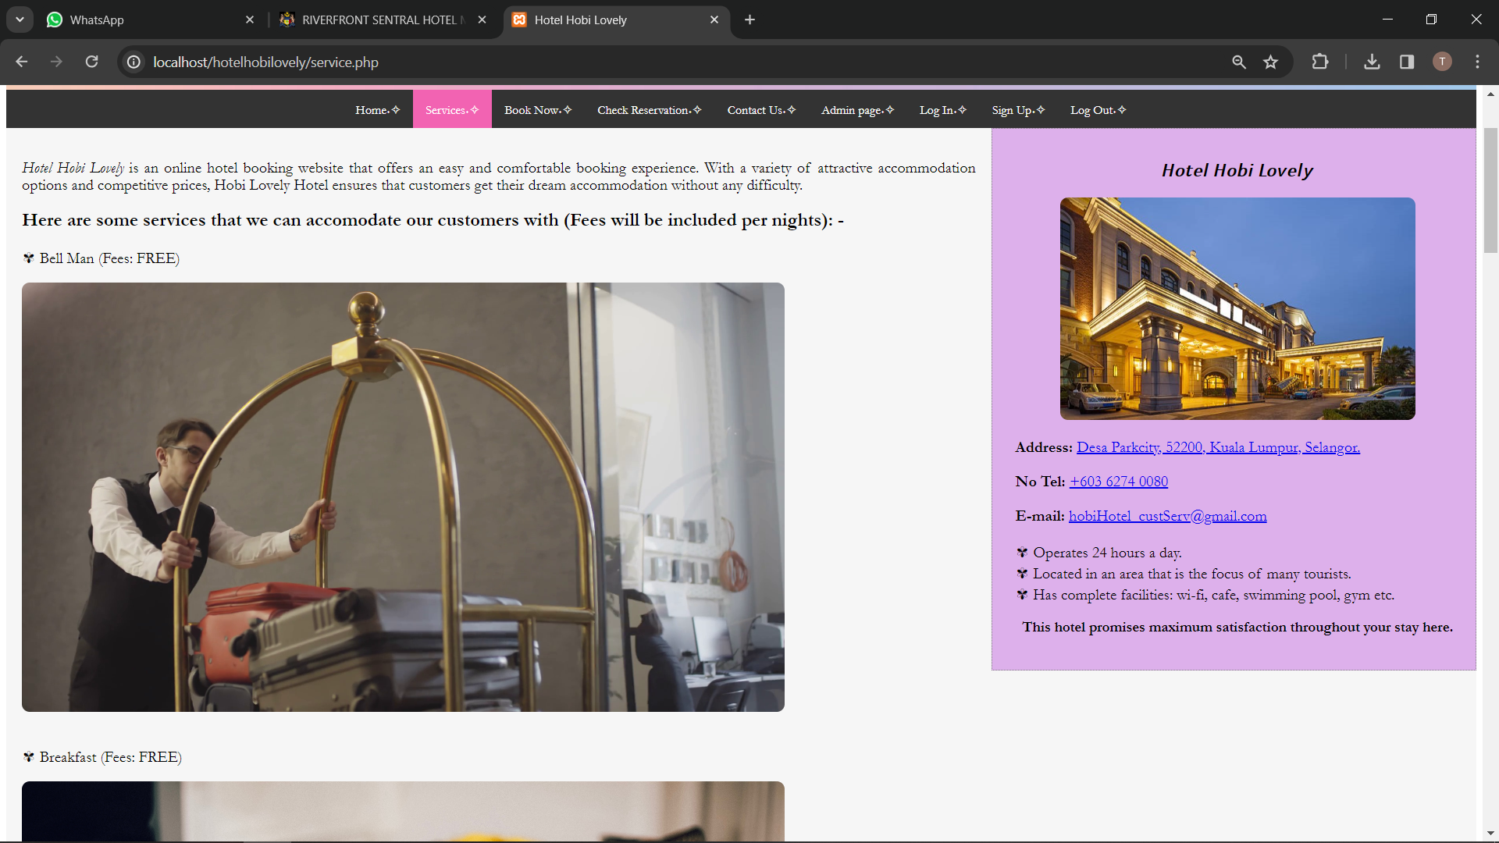

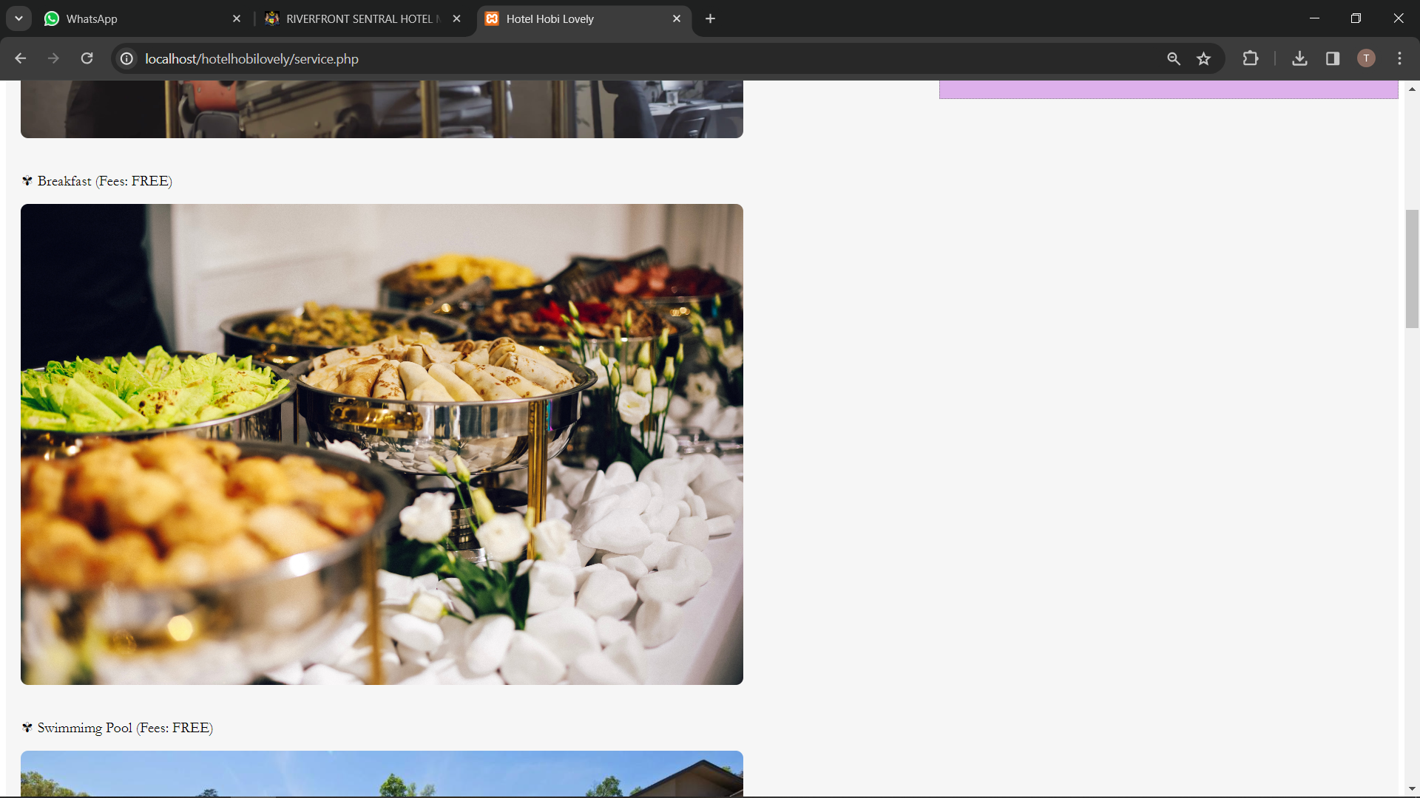

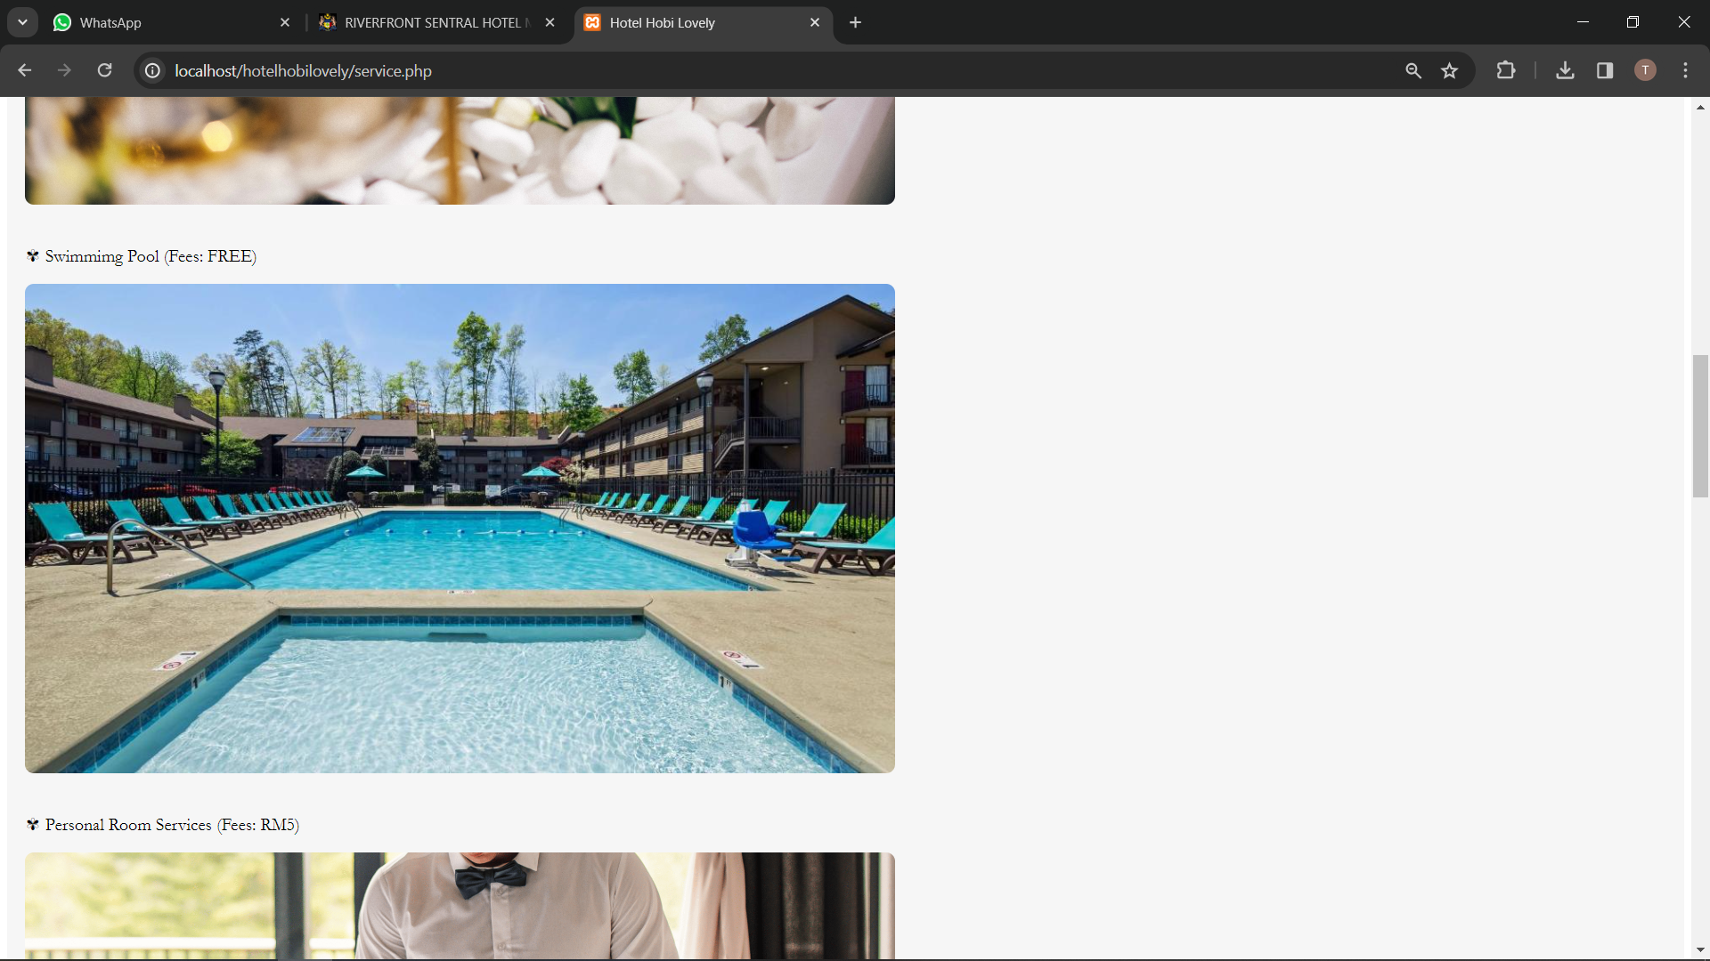

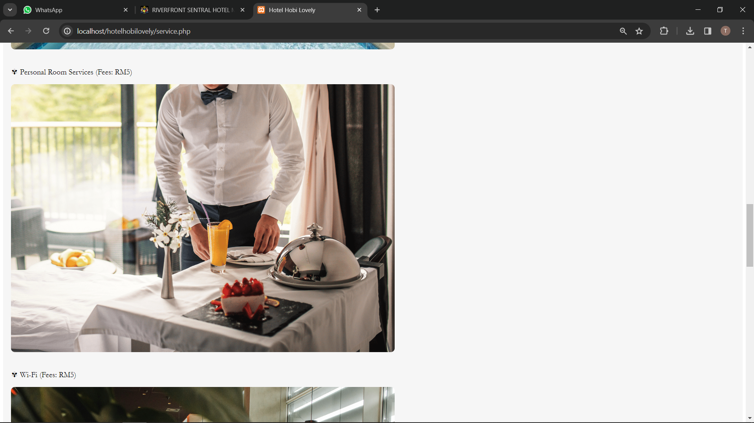

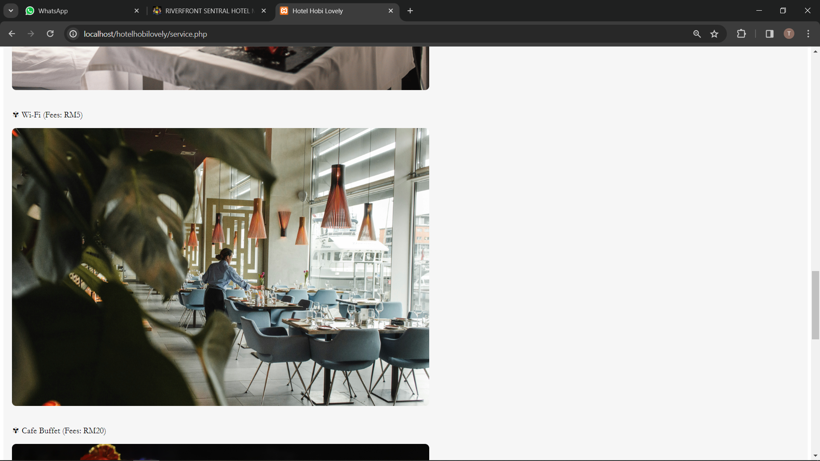

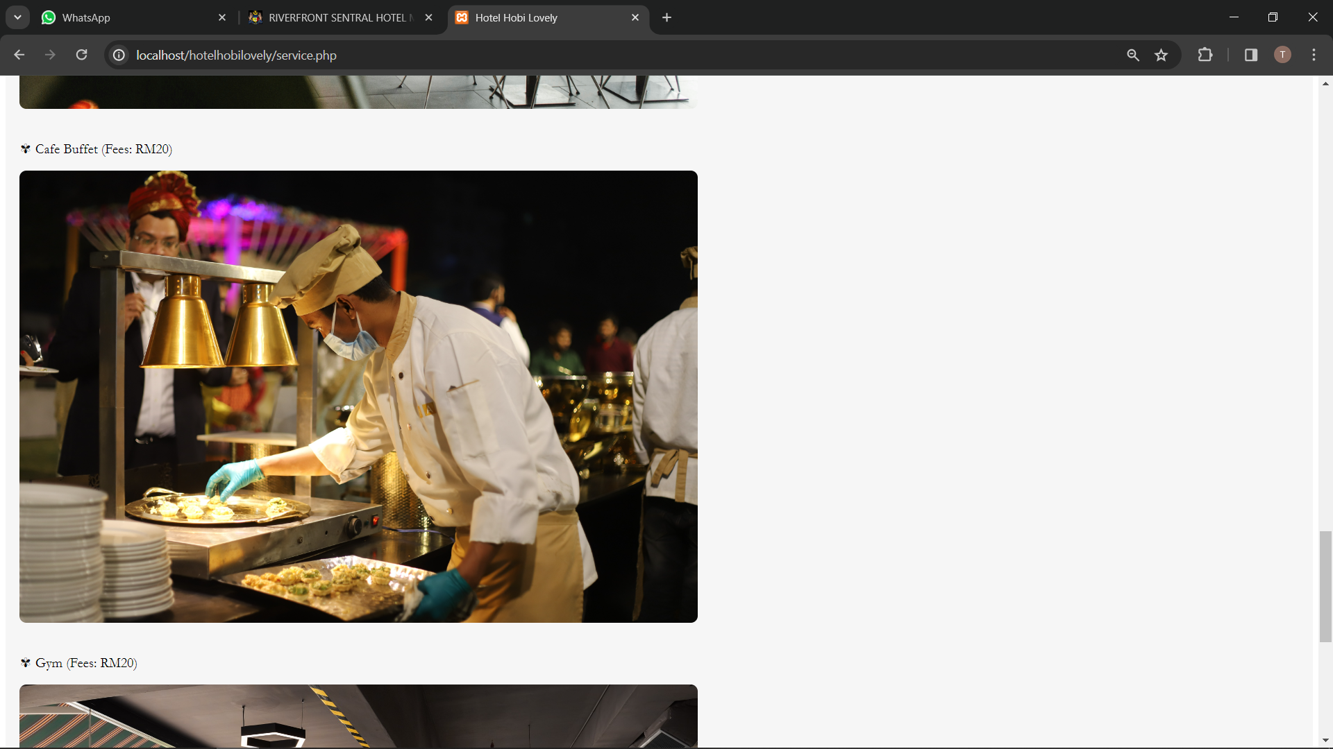

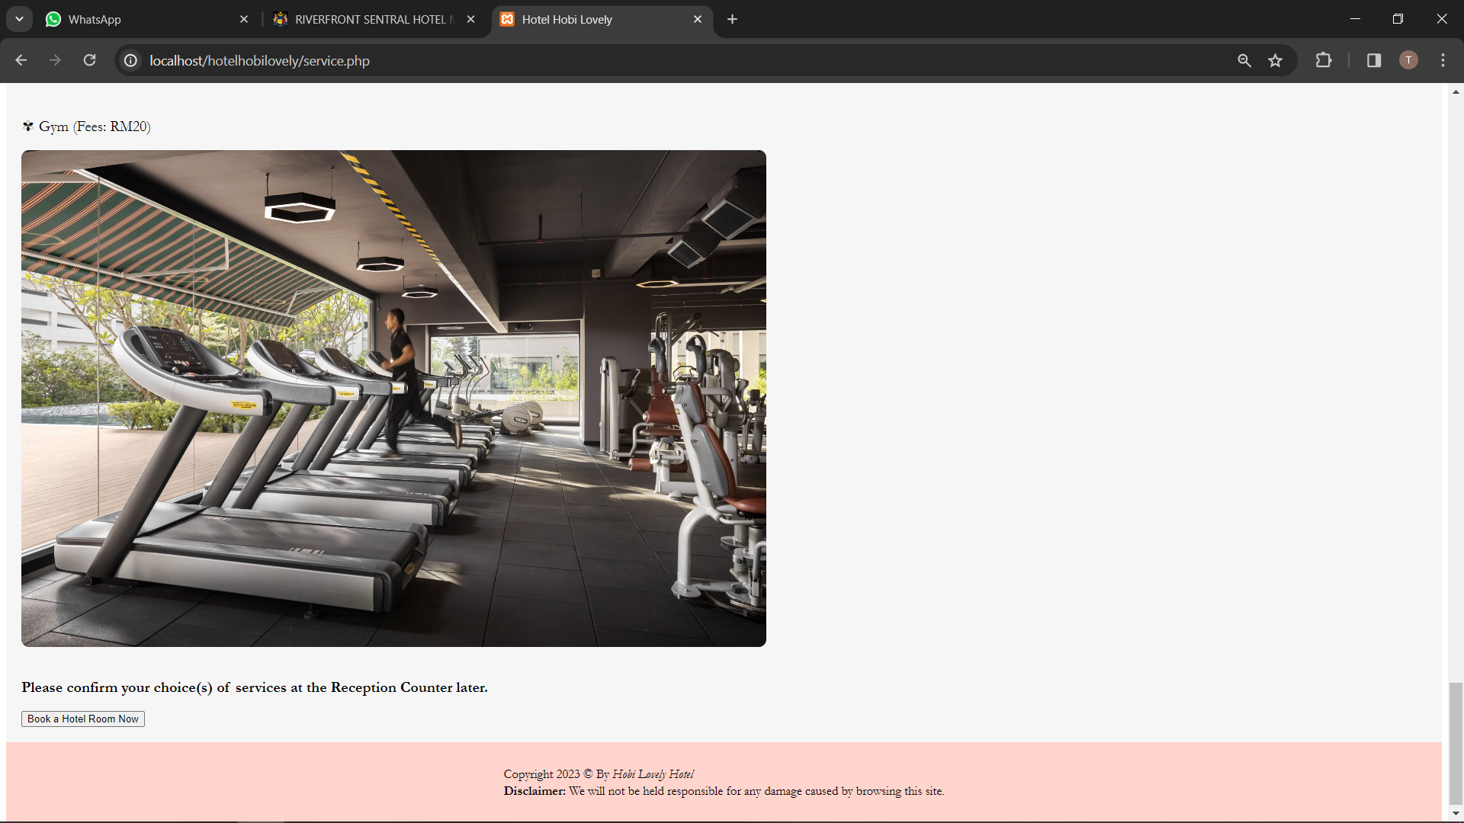

### Book Now Page

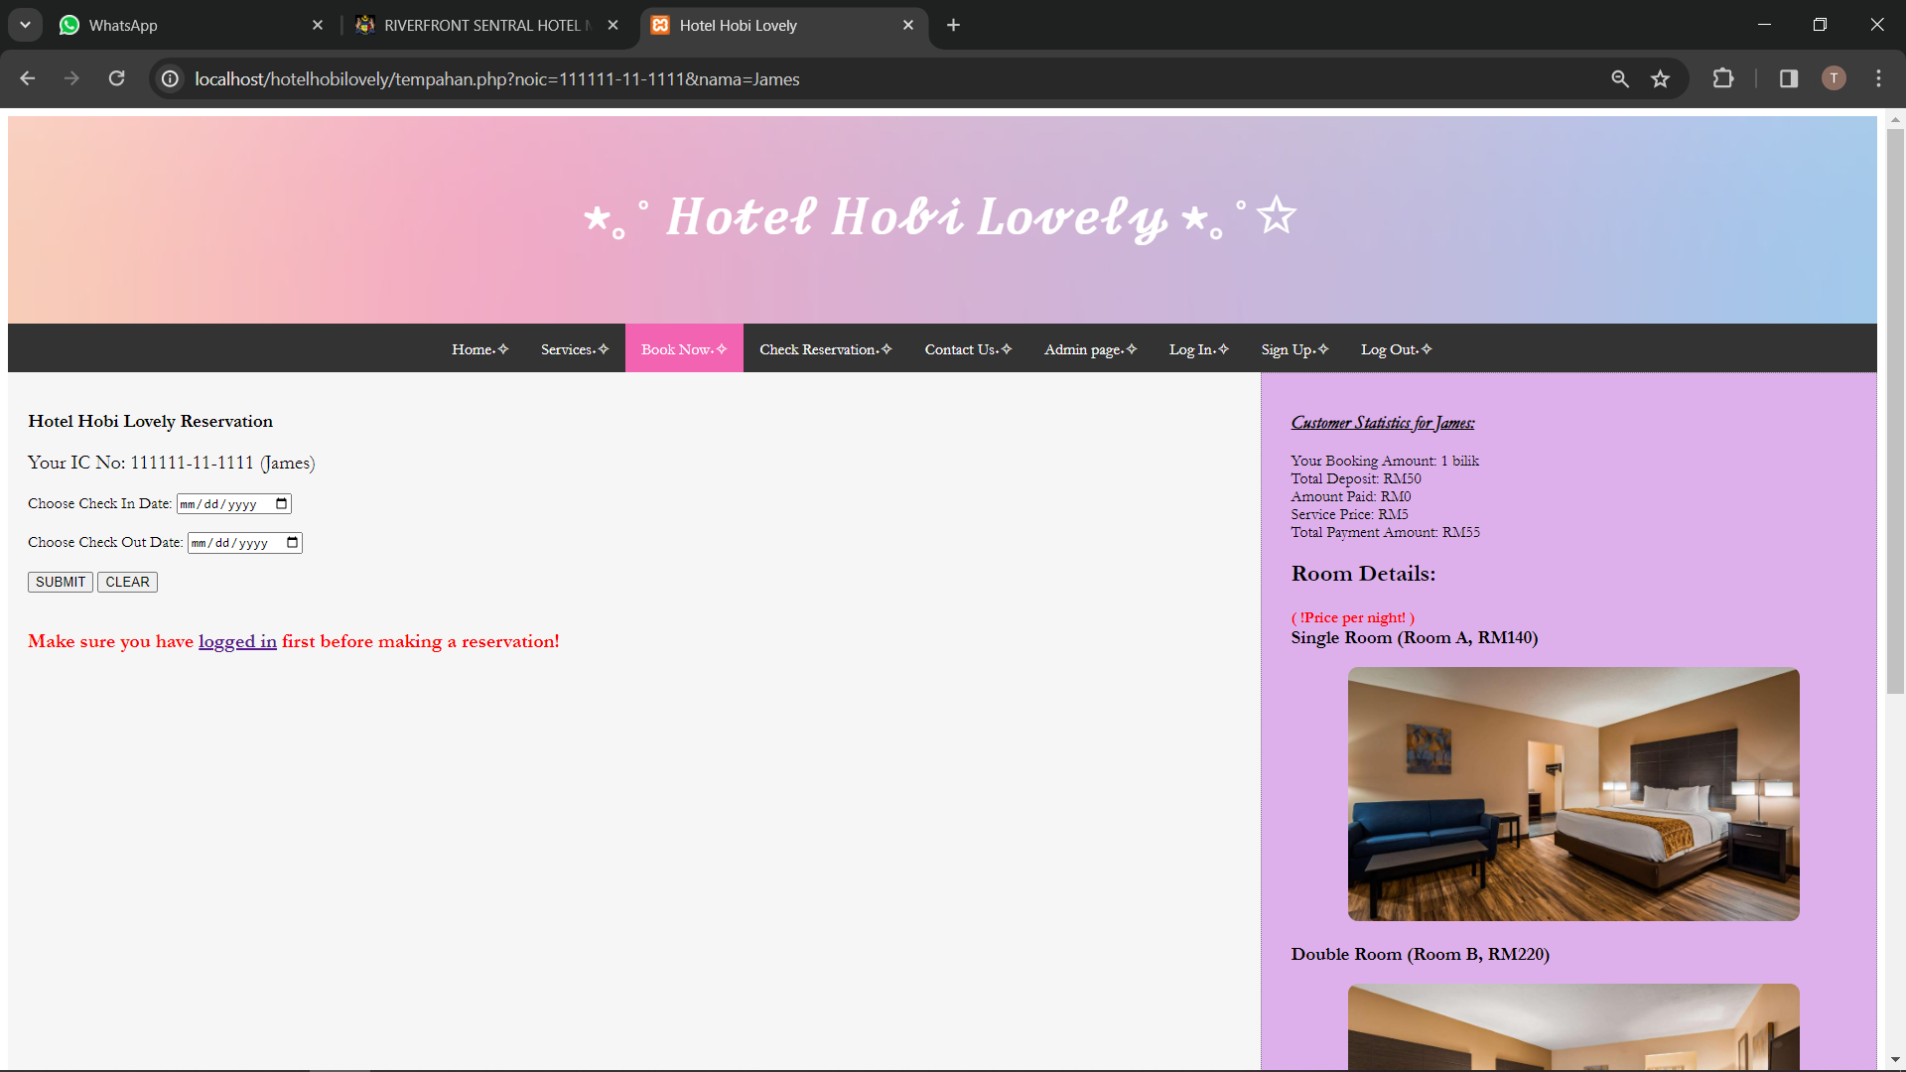

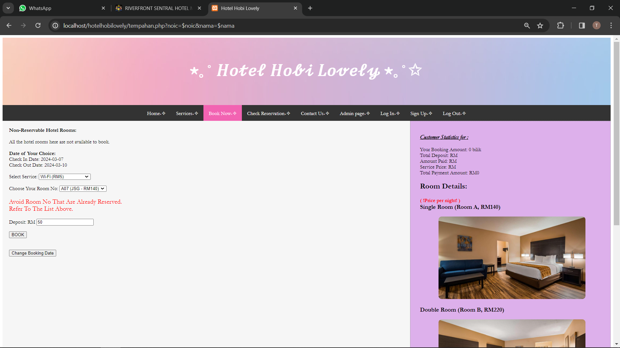

### Check Reservation Page

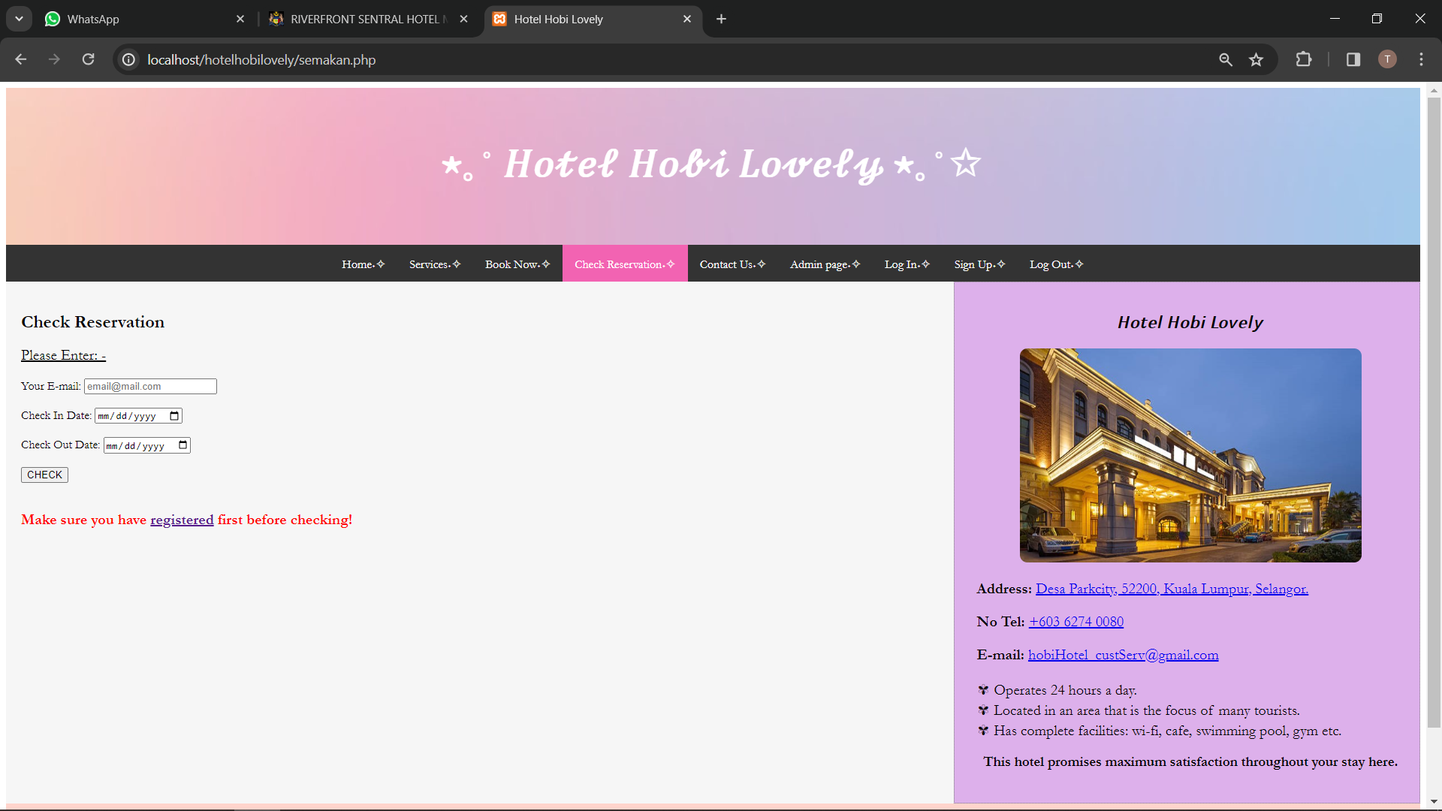

### Contact Us Page

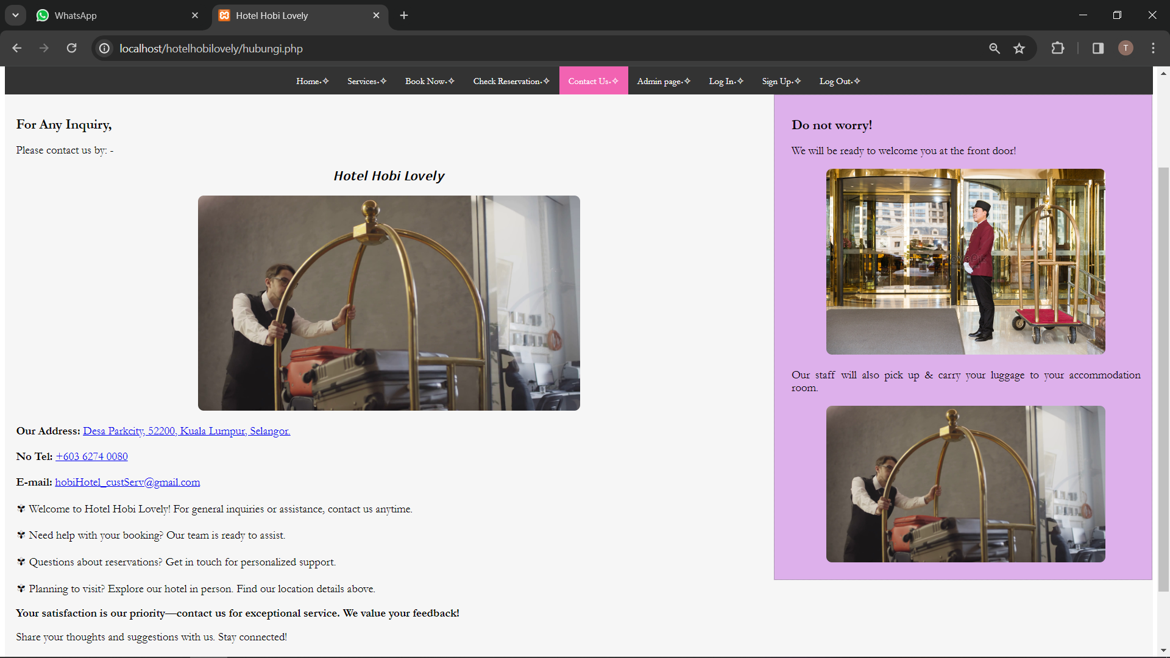

### Admin Page

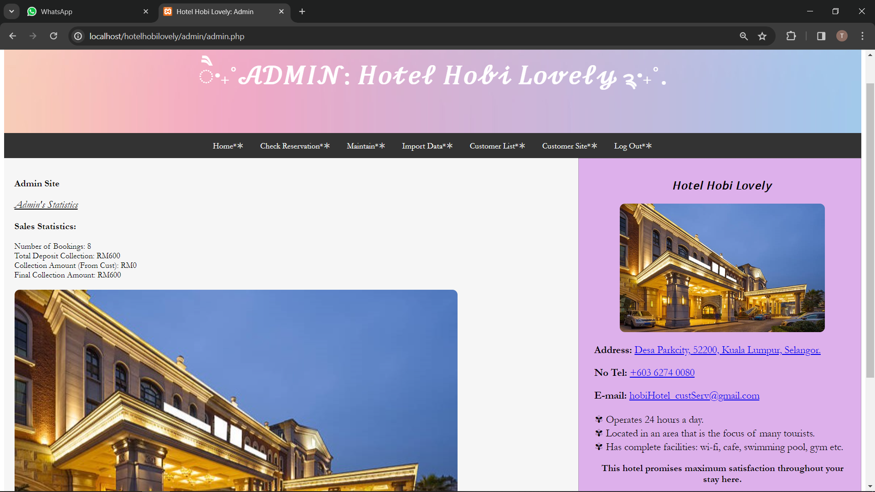

### Admin Check Reservation Page

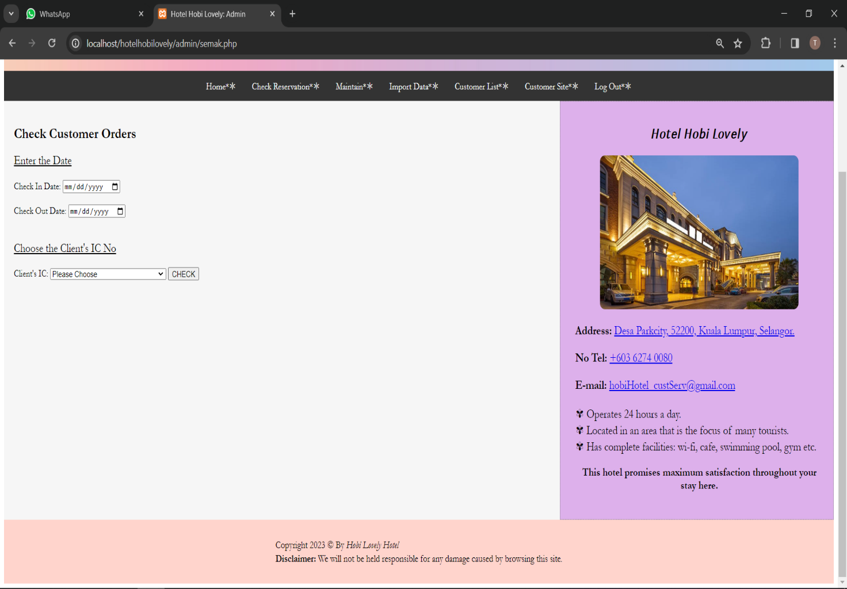

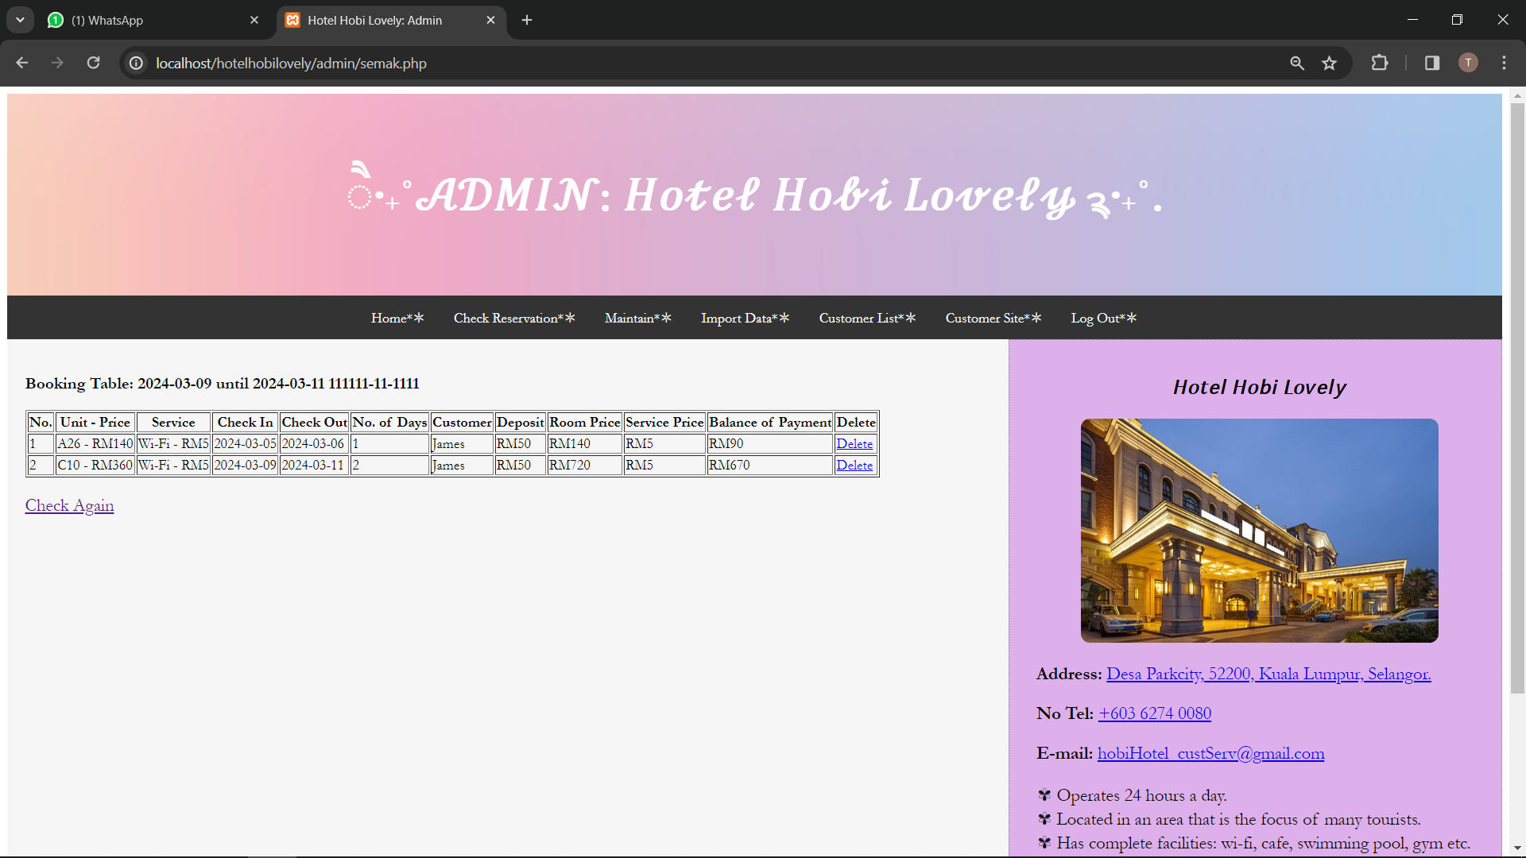

### Admin Customer Payment Page

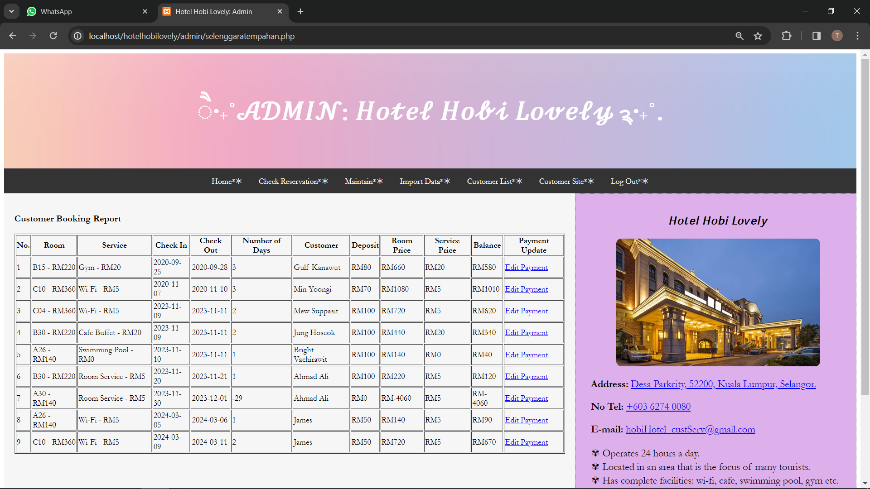

### Admin Check Room ID Page

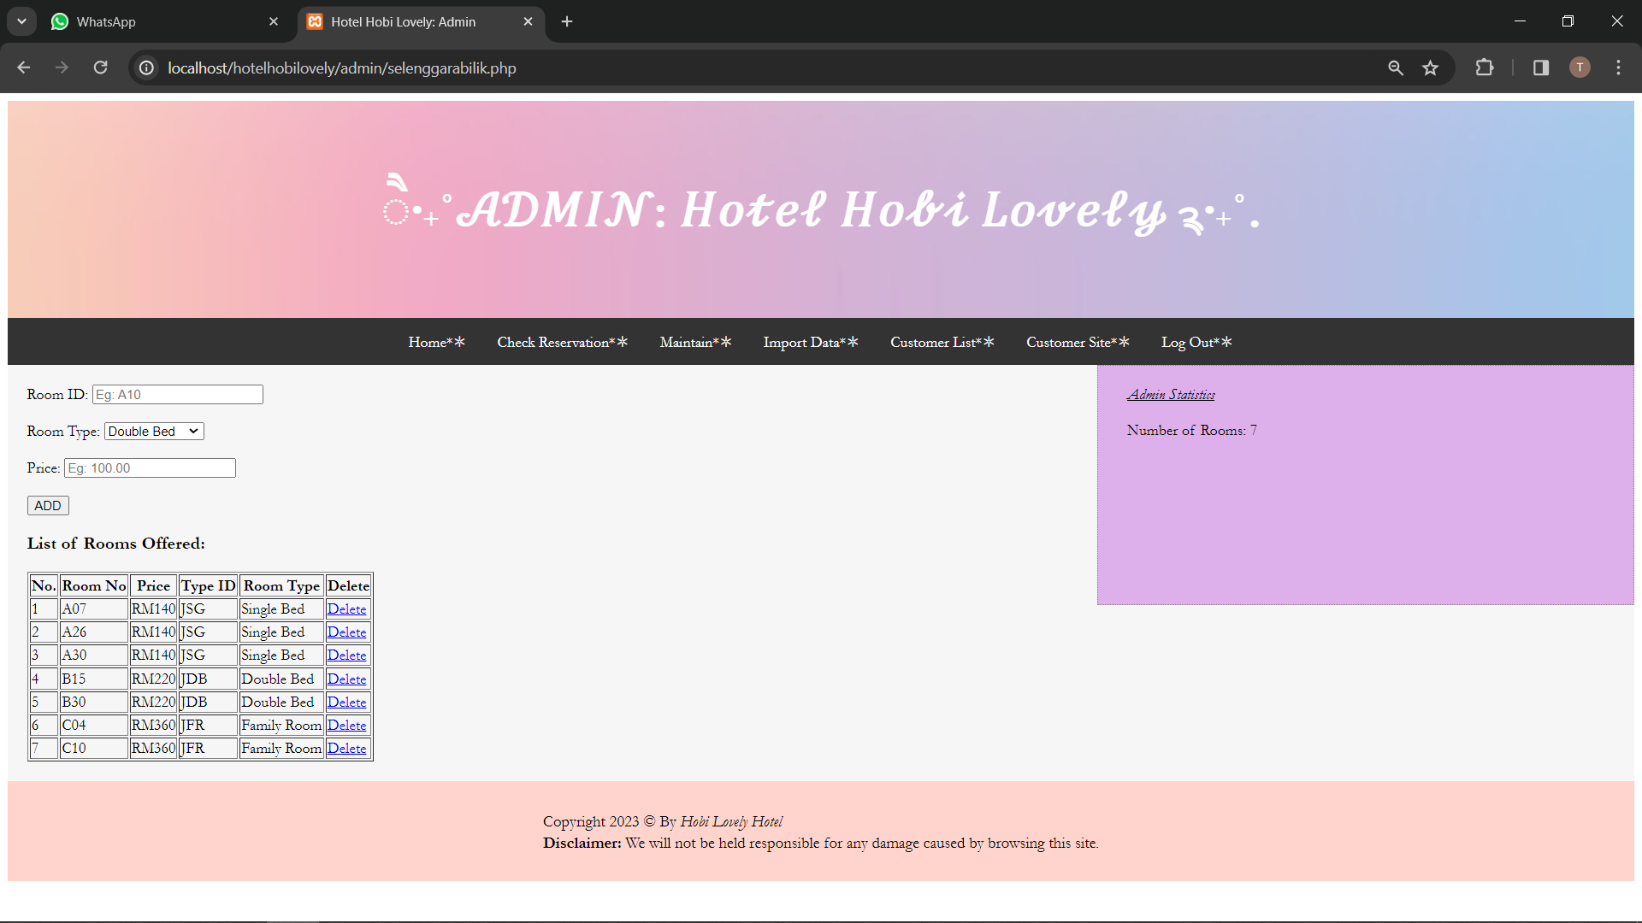

### Admin Check Room Type Page

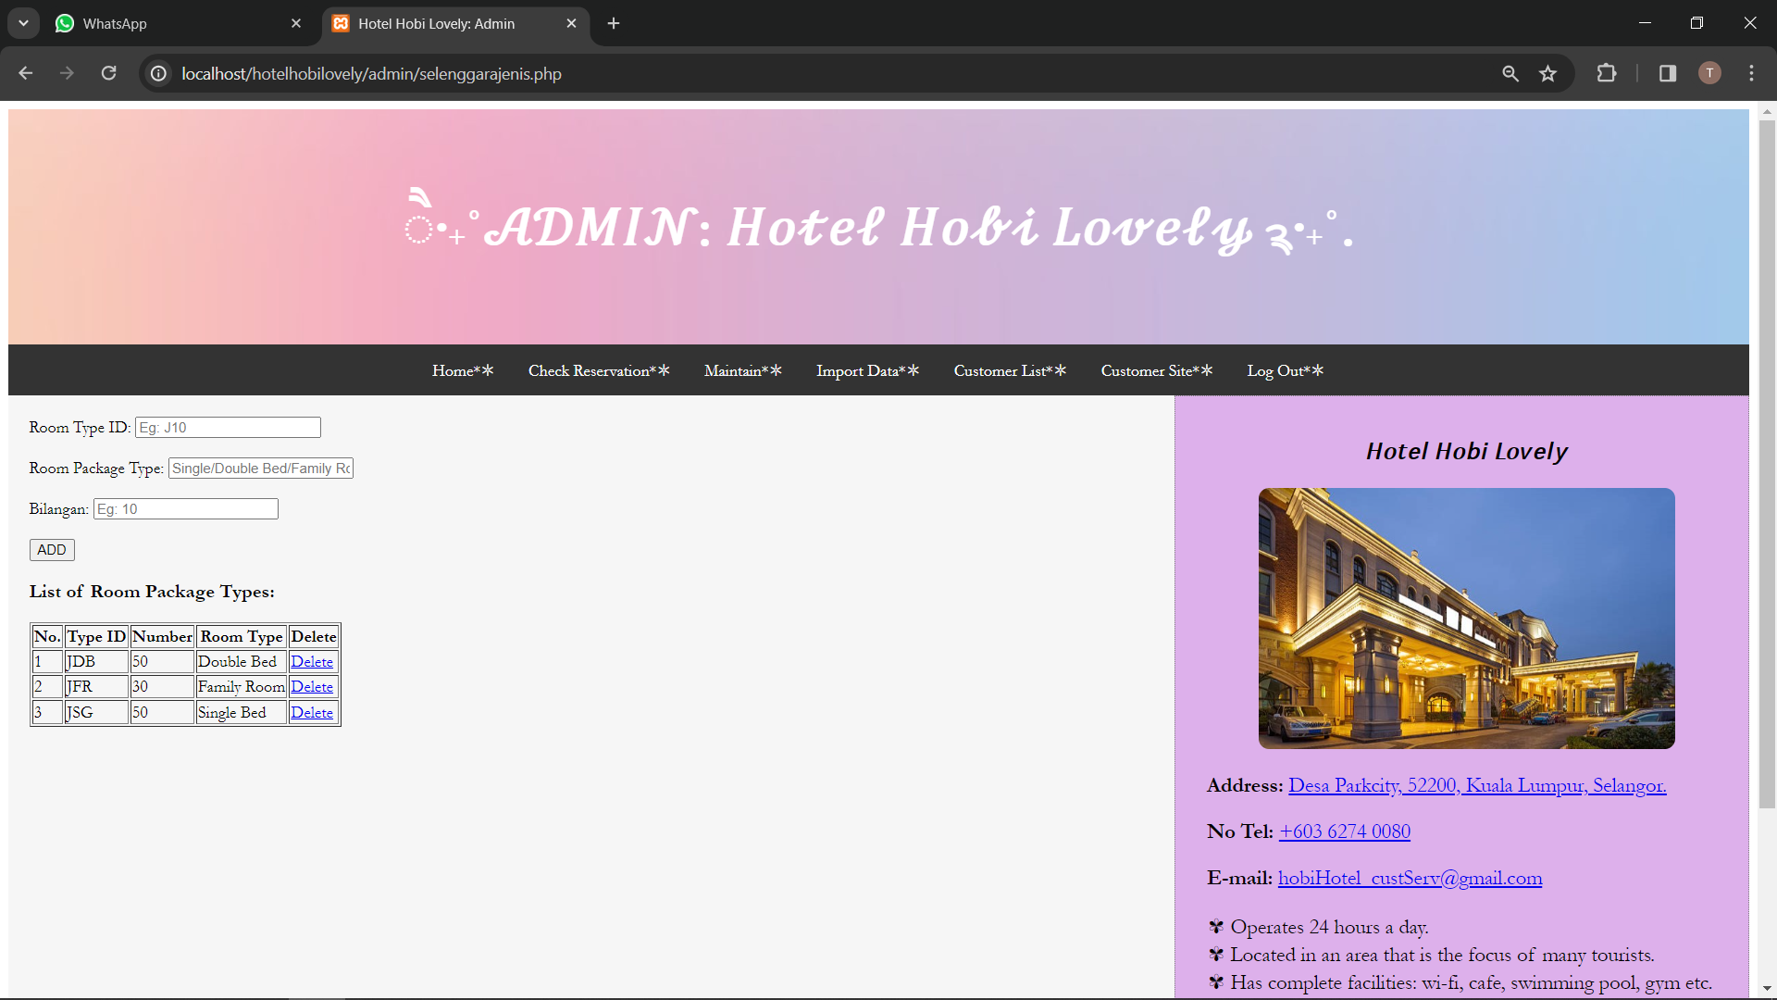

### Import Data Page

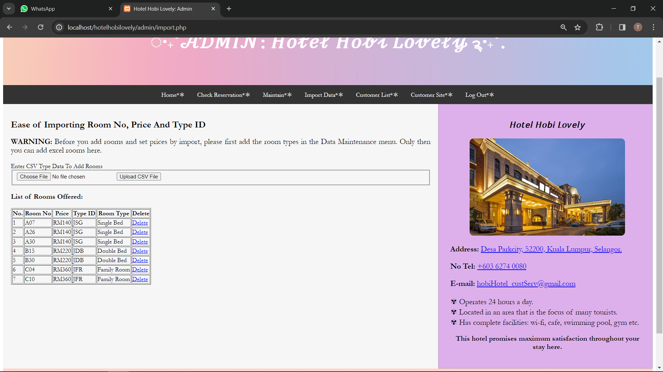

### Admin Customer List Page

### Log Out Page

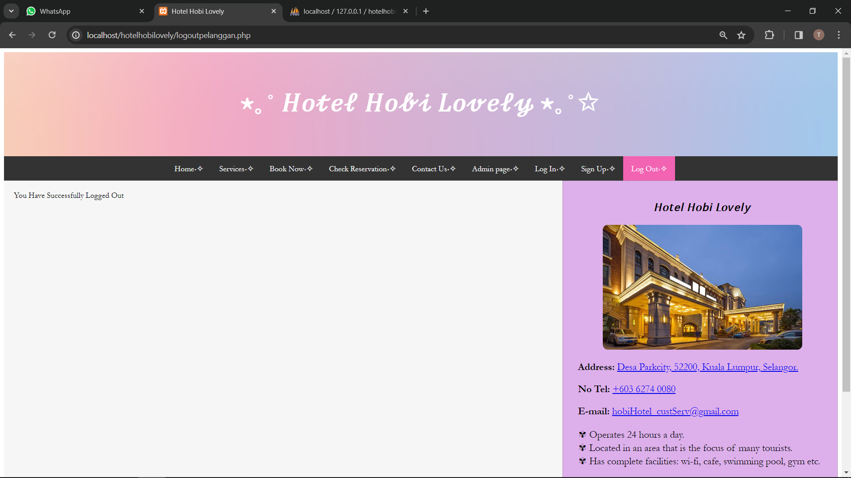

## Source Code for All Files

<https://drive.google.com/drive/folders/1xNQ_7_RWzIe5jAhoIEG1cqPvGxTg_Ync?usp=sharing>

# Database

## ER-Diagram for the Database

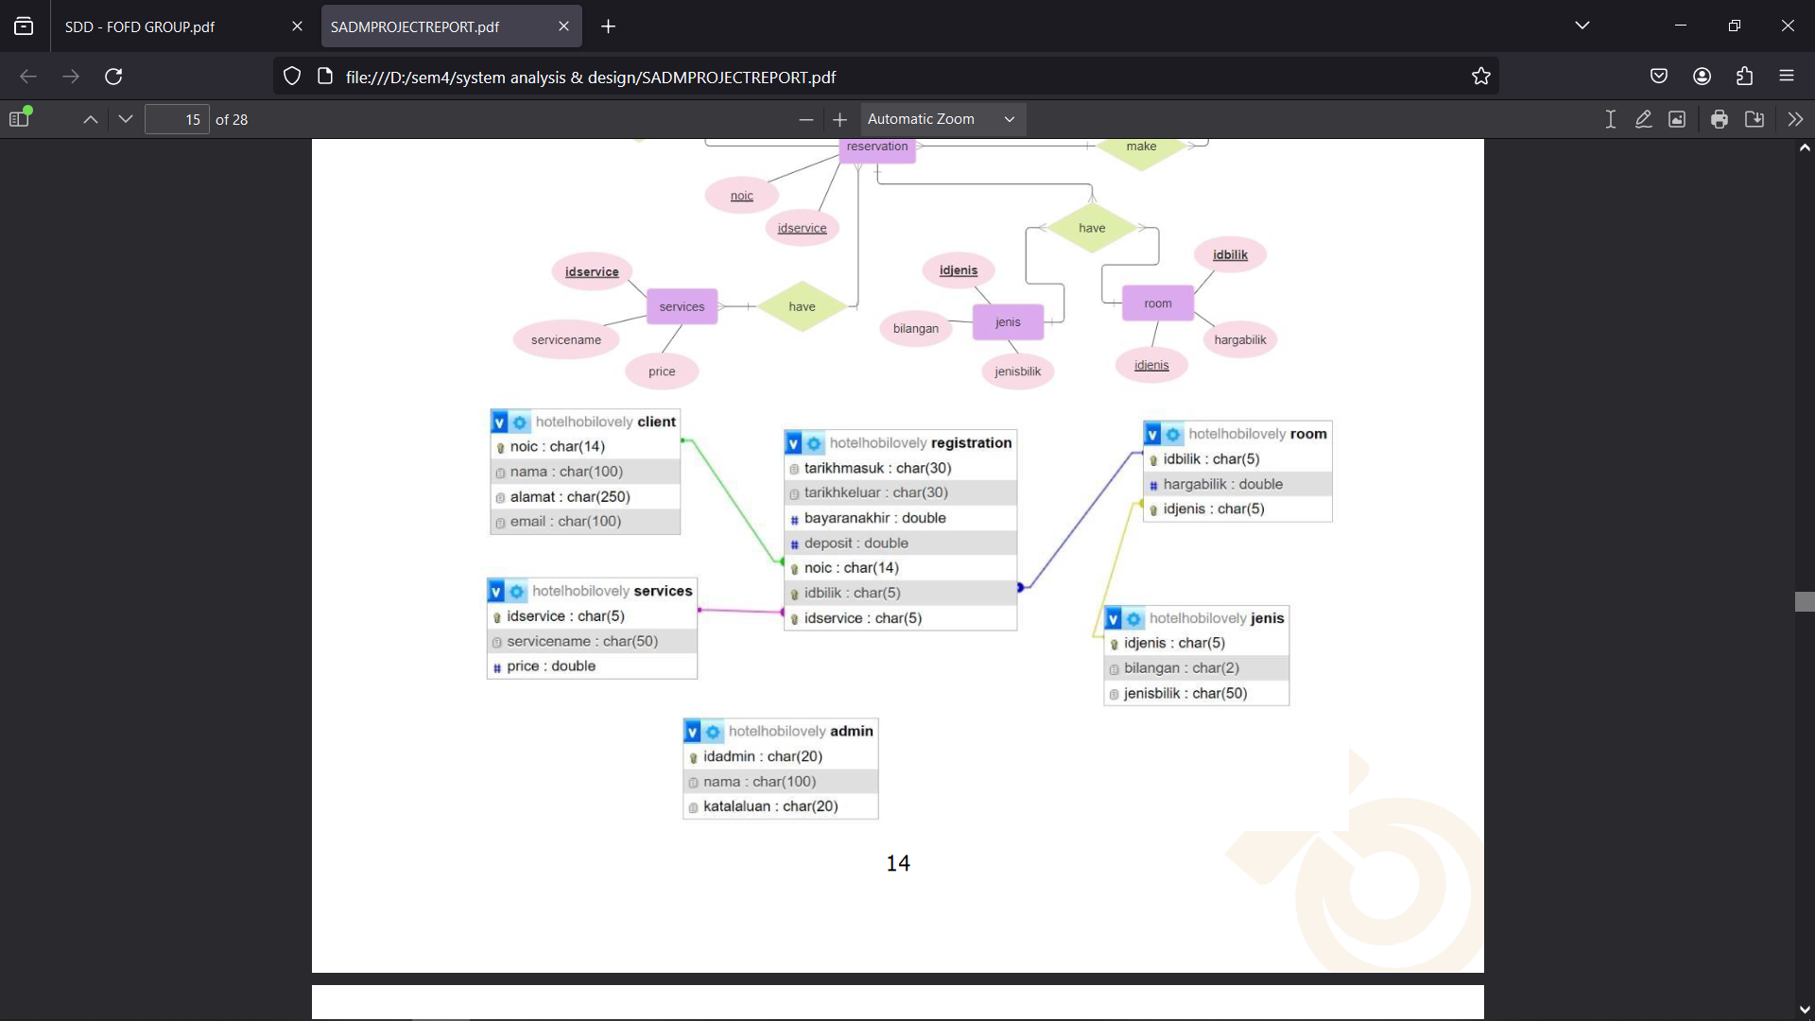

## 

## Sereenshot of DataBase

### 

### Admin Table

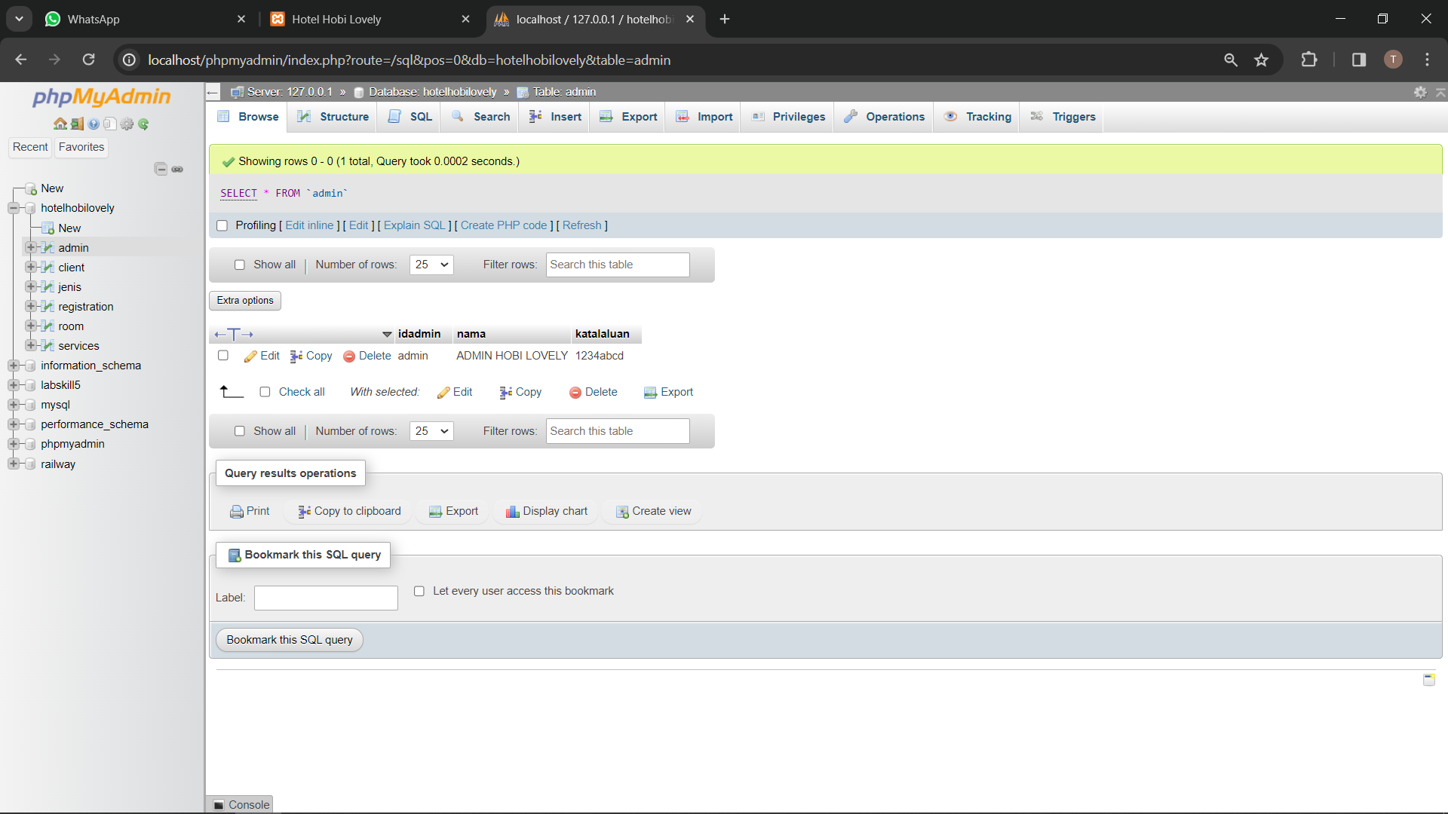

### 

### Client Table

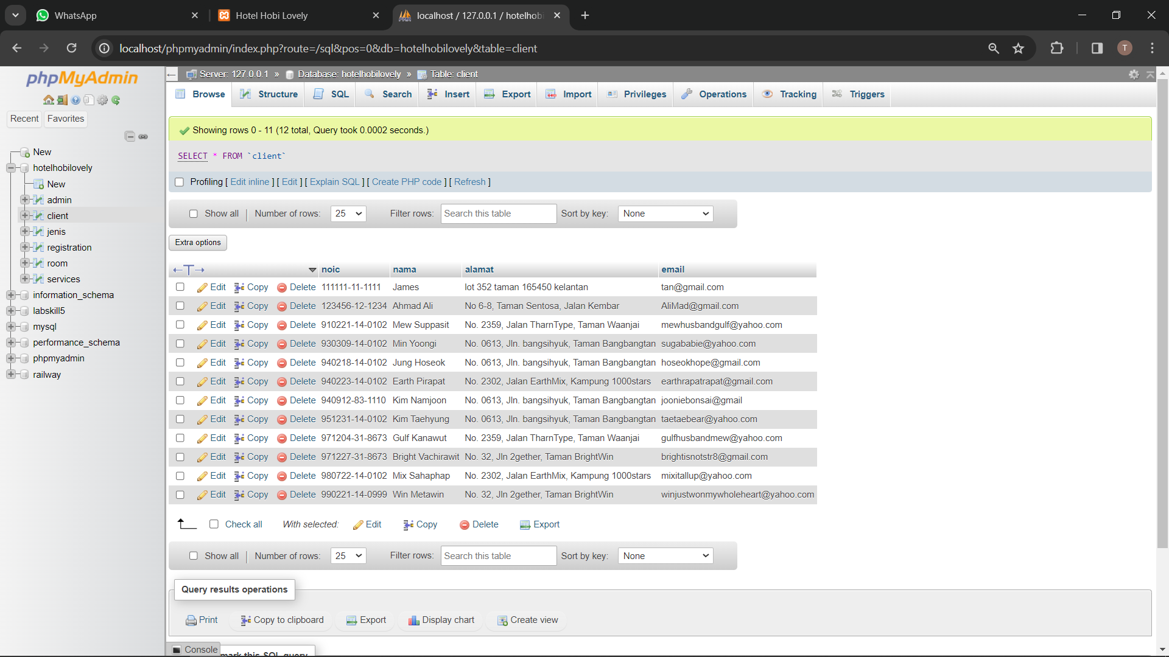

### Room Type Table

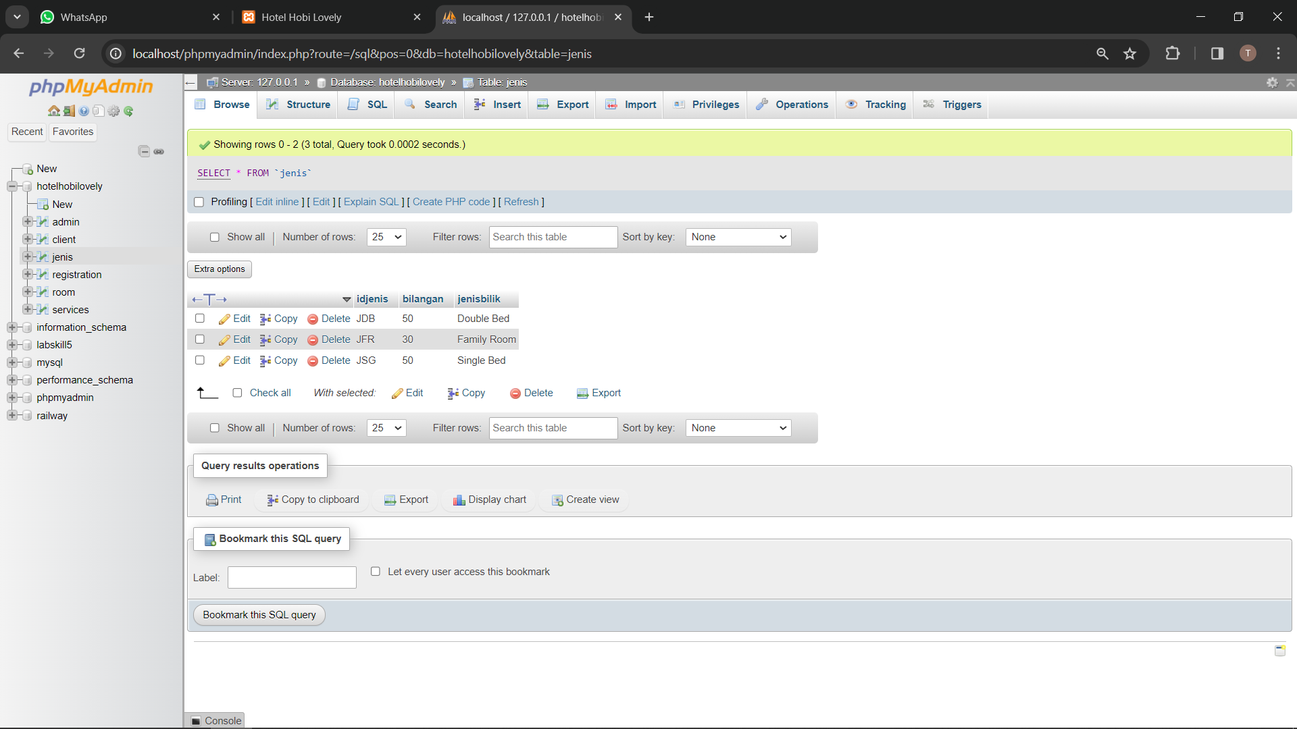

### Registration Table

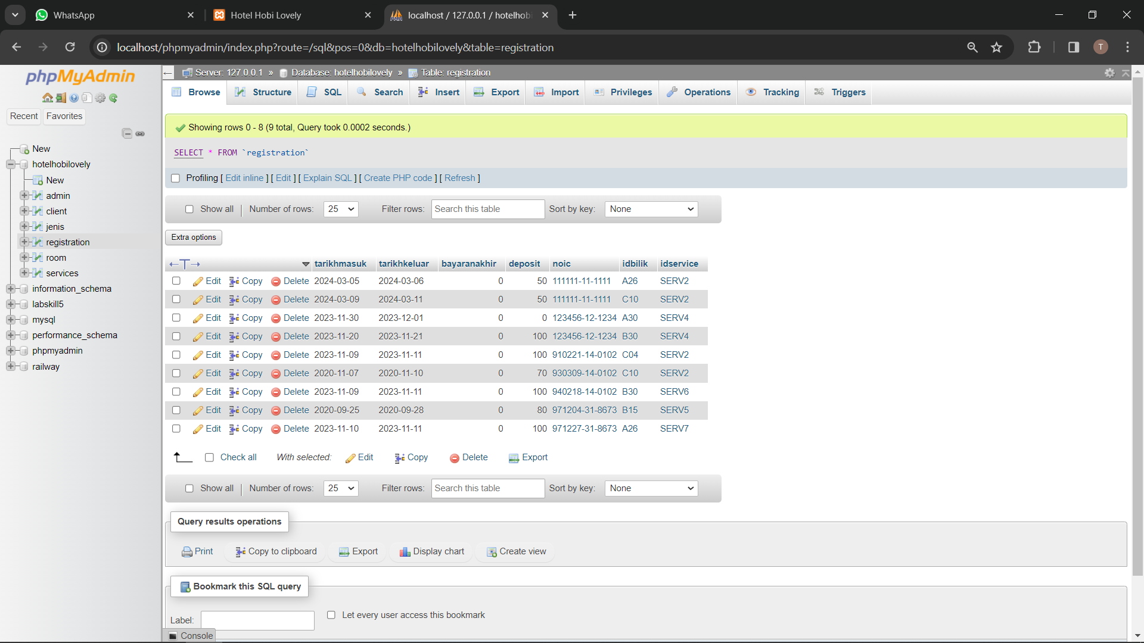

### A screenshot of a computer Description automatically generatedRoom Table

### Service Table

## SQL Statement for the Database / No-SQL Rules in Firebase

Database: Hotelhobilovely

**1. Table structure for table `admin`**

CREATE TABLE `admin` (

‘idadmin’ char (20) NOT NULL,

‘nama’ char (100) NOT NULL,

‘katalaluan’ char (20) NOT NULL,

) ENGINE=InnoDB DEFAULT CHARSET=laGn1;

**2. Table structure for table `client`**

CREATE TABLE `client` (

‘noic’ char (14) NOT NULL,

‘nama’ char (100) NOT NULL,

‘alamat’ char (250) NOT NULL,

‘email’ char (100) NOT NULL,

) ENGINE=InnoDB DEFAULT CHARSET=laGn1;

**3. Table structure for table `Jenis`**

CREATE TABLE `Type` (

‘idjenis’ char (5) NOT NULL,

‘bilangan’ char (20) NOT NULL,

‘jenisbilik’ char (50) NOT NULL,

) ENGINE=InnoDB DEFAULT CHARSET=laGn1;

**4. Table structure for table `Registration`**

CREATE TABLE `Registration` (

‘tarikhmasuk’ char (30) NOT NULL,

‘tarikhkeluar’ char (30) NOT NULL,

‘bayaranakhir’ double NOT NULL,

‘deposit’ double NOT NULL,

‘noic’ char (14) NOT NULL,

‘idbilik’ char (5) NOT NULL,

‘idservice’ char (5) NOT NULL,

) ENGINE=InnoDB DEFAULT CHARSET=laGn1;

**5. Table structure for table `Room`**

CREATE TABLE `Room` (

‘idbilik’ char (5) NOT NULL,

‘hargabilik’ double NOT NULL,

‘idjenis’ char (5) NOT NULL,

) ENGINE=InnoDB DEFAULT CHARSET=laGn1;

**6. Table structure for table `Room`**

CREATE TABLE `Room` (

‘idservice’ char (5) NOT NULL,

‘servicename’ char (50) NOT NULL,

‘price’ double NOT NULL,

) ENGINE=InnoDB DEFAULT CHARSET=laGn1;